Weather Station for NASA GLOBE

Boston University

Department of Mechanical Engineering

ME 461 Senior Capstone Experience A2

Team Citizen Science

Chitanya Gopu, David Martinez, Hayley Walker, Michelle Ye

May 3, 2017

Project Customer: Professor Farny

Faculty Advisor: Professor Gutierrez-Wing

Final Report

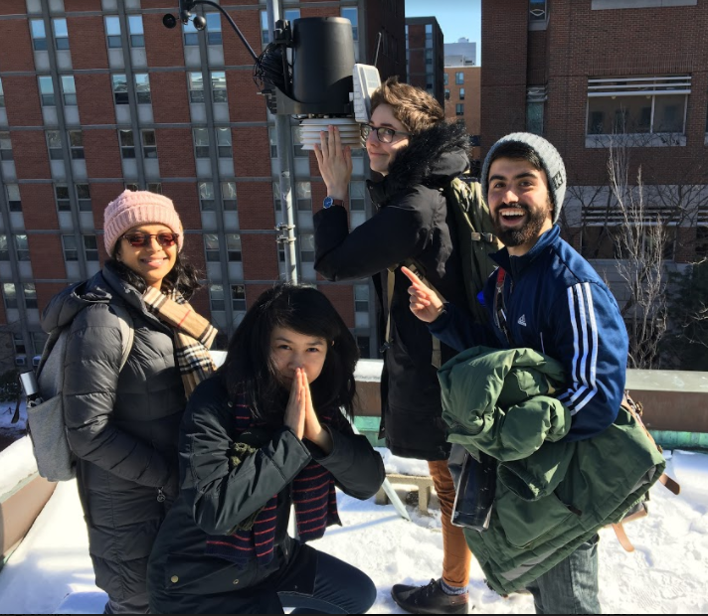

PRELIMINARY INTRODUCTION

ABSTRACT

The Earth’s atmosphere is changing rapidly. To accurately track weather patterns over time and to meaningfully understand the environment, U.S. National Aeronautics and Space Administration (NASA) and the National Science Foundation (NSF) sponsor the Global Learning and Observations to Benefit the Environment (GLOBE) program to collect weather data worldwide. Not only do scientists contribute data to NASA GLOBE’s program, but average citizens and students can participate as well to encourage “citizen science”, educating the public while accomplishing GLOBE’s main mission.

Our role in GLOBE’s mission is to provide high schools with an affordable, accessible and portable weather station kit for the students to build and then implement in their schools, contributing to real climate science data collection. This engages the students in environmental education, while teaching fundamental mechanical and electrical engineering skills that encourage STEM education.  
  
Our weather station is relatively cheap, solar powered, and wirelessly plots data in real-time on an online data analytics platform with the Arduino IDE. The system measures temperature, humidity, pressure and wind speed using a breakout board and anemometer, with a custom designed electronics housing and a roof mount. A prototype of the weather station and educational material has been successfully tested and approved by Fenway High School students.

**Table of Contents**

|  |  |  |
| --- | --- | --- |
| Abstract |  | 1 |
| List of Figures |  |  |
|  | *Figure 1. Full weather station on a roof, without the connection of wires* | 10 |
|  | Figure 2 .*Close up of the weather station on the roof* | 10 |
|  | Figure 3. *Functional Architecture of the entire weather station kit* | 11 |
|  | Figure 4. *Functional Architecture of the electronic components of the project (Linear display from data collection to GLOBE)* | 11 |
|  | *Figure 5. Functional Decomposition of the Weather Station* | 12 |
|  | *Figure 6. Pictorial Representation of a Sensor* | 14 |
|  | *Figure 7. Pictorial Representation of ESP8266 Huzzah!* | 14 |
|  | *Figure 8. Pictorial Representation of Power Boost 1000* | *15* |
|  | *Figure 9. Pictorial Representation of a solar panel connected to a rechargeable battery* | 15 |
|  | *Figure 10. Pictorial Representation of store bought anemometer* | 16 |
|  | *Figure 11. Schematic of the Electronics Component* | 16 |
|  | *Figure 12. Picture of the Electronics Component inside Housing* | 17 |
|  | *Figure 13. Current design for the FS anemometer* | 19 |
|  | *Figure 14. The Encoder Wheel* | 20 |
|  | *Figure 15. The circuit schematic for the photointerrupter and arduino* | 21 |
|  | *Figure 16. The FS Anemometer* | 22 |
|  | *Figure 17. Anemometer Calibration* | 23 |
|  | *Figure 18. The FS Anemometer with electrical components.* | 24 |
| Executive Summary | | 33 |
| Acknowledgements | | 34 |

**Body of the Report**

|  |  |  |
| --- | --- | --- |
| Introduction and Background | | 4 |
|  | Problem Statement | 5 |
|  | Meeting the Customers | 6 |
| Customer Requirements | | 7 |
| Engineering Specifications (Technical Requirements) | | 8 |
| Design Description |  | 10 |
|  | Functional Architecture | 11 |
|  | Functional Decomposition | 12 |
|  | Operation of Mechanisms | 13 |
|  | How to use our Weather Station | 24 |
| Design Decisions |  | 25 |
| Design Evaluations |  | 30 |
|  | Project Week Evaluation | 30 |
|  | Technical Design Evaluation | 31 |
| Market/Cost Analysis |  | 31 |
| Conclusions |  | 32 |
|  | Recommendations | 32 |

**Appendices**

|  |  |  |
| --- | --- | --- |
| A. Bill of Materials | | 35 |
| B. Pugh Charts | | 37 |
| C. SNR Calculations | | 40 |
| D. SNR Graph | | 40 |
| E. Anemometer Calibration Data | | 41 |
| F. Arduino IDE Code | | 43 |
| G. FS Anemometer Arduino IDE Code | | 48 |
| H. Working Drawings | | 51 |
| I. GLOBE Specifications | | 55 |
| J. Gantt Chart | | 57 |
| K. Project Week Agenda | | 57 |
| L. Data Graphs | | 60 |
|  | Project Week Results | 60 |
|  | Extended Period Testing | 61 |

INTRODUCTION AND BACKGROUND

GLOBE stands for Global Learning and Observations to Benefit the Environment (GLOBE) Program is an “international science and education program that provides students and the public worldwide with the opportunity to participate in data collection and the scientific process, and contribute meaningfully to our understanding of the Earth system and global environment”[1]. In short, it encourages citizen science, which means getting citizens to be more involved in science, to gather climate related data while providing NASA with real time data from around the world. The climate science data is gathered from satellites and from ground based data. GLOBE works closely with NASA, NOAA (National Oceanic and Atmospheric Administration) and NST(National Science Foundation) in study and research about the dynamics of the Earth’s environment[2].

Boston University is one of seven schools that has a partnership with GLOBE. Through GLOBE, there is a grant available in order to get more students K - 12 more exposure in STEM, particularly for underrepresented districts.

In this particular senior project, the GLOBE partnership will be used to help the school system in Providence, Rhode Island. The target area of Providence, RI stems from the differences in education systems between RI and Boston. Some factors include the superintendent having a strong influence as compared to the school systems in Boston. In Boston, there is a strong teacher’s union so change is more on a school by school basis, which makes STEM programs such as this more difficult to implement. In RI, the superintendent can push programs such as this one city wide in Providence, which will reach more schools faster.

An initial prototype was created and tested by Fenway High School students. This prototype consisted of three main components - learning about sensors, connecting wifi to the system, and creating a housing for the entire system. It was immensely successful, more information can be found below in the “Project Week” section.

**Problem Statement**

GLOBE is a NASA based organization that collects ground climate data from citizens for integration with satellite data[3]. Existing products available to the general public that collect climate data, such as the Davis weather station, cost $595 - $650 and are ready-made[4].This project aims to create a portable weather station that would qualify to collect data for GLOBE on the citizen level, and will subsequently develop an instruction manual and educational materials to make this process reproducible in high school curriculum. This product comes in the form of a kit with instructions for students to build as an STEM education tool, allowing the students to gain hands-on engineering experience for real world applications.

High school students are not exposed to technical/engineering skills often. When they are, the mechanics and electrical theory behind the instruments used are not covered (use is explored, but not technical decomposition). Additionally, existing tech programs/clubs do not involve a learning partnership, and are not centered around instrumentation, an extremely useful engineering skill. Lastly, current instruments and tech projects are costly, and something not all school districts can afford. This project would bring technical engineering skills that are often overlooked into the scientific data collection process for high schoolers.

*Essential question:* How can we implement a cost efficient educational program that allows students to become citizen scientists while learning technical engineering skills? How can this program and device be interactive and user friendly for citizen and student scientists? How can this contribute to a real data pool to help organizations like NASA?

There are several constraints on the design of the instrument. First, the product must cost under $500, to compete with competitor products, and must be finished before April 30th. The product must be weatherproof and animal proof, as it will experience prolonged periods of outdoor exposure. This ensures that the product will last at minimum 5 years for the school system to use. Following up on school system usage, the product must be durable and take into account the technical abilities of the students. This is a precaution to ensure that the product is designed for their their use. Other constraints to simplify data collection involve wireless capabilities to transmit data. Lastly, the system must be powered wirelessly (a solar panel and battery is the preferred method), as it will be mainly operational on a rooftop. The final constraint is to ensure that all the components of the product are “off the shelf” since most schools do not have machine shops or complicated manufacturing and prototyping equipment.

This product is one of the best in the market. As compared to our competitors, the Davis Weather Station, the Gutierrez Weather Station is projected to be cheaper than our competitors by over 50% and it also comes with an interactive component to allows kids to have a more hands on experience. The educational resources are plentiful and impactful by promoting STEM and engineering. The overall goal is to provide lower income school districts with an easy to use product that helps foster students with early exposure to the sciences and engineering fields.

**Meeting the Customer**

This project responds to the needs of two customers, for which the team built, tested, and executed the final product: Professor Farny, the primary customer, and Fenway High School, a supplemental customer.

The primary customer is Professor Farny. He introduced this project and from his requests, the goal was determined. The ultimate goal is to provide Providence Rhode Island Public Schools with a low-cost weather - instrumentation kit suitable for use in high school education and GLOBE research. His set of requirements were to create the kit from “off-the-shelf” products (minimal machining), for the kit to cost less than $500, for the device to connect to GLOBE, and for a detailed educational instruction manual to go with the overall project. The instruction manual should be targeted to high school students and should contain information about the science, and mainly the engineering processes involved. Other requirements include having the prototype be wireless, self-powered, roof mountable, and waterproof. In terms of housing, it needs to cover the electronic components, while still allowing the sensors and solar panel to air, wind, and the sun so all the pieces must be mounted together. The exposed elements need to be connected without wires and electronics being exposed to weather that can cause damage, specifically water damage.

*Here are the specific aims for this project:*

1. Research & choose sensors for the device
2. Design housing to fit the sensors and anemometer, and mount overall device to rooftop
3. Connect to wifi connectivity for continuous data uploading
4. Design to be self powered
5. Create an instruction manual on how to build, description of sensors, and handy tips

In order to get a better understanding of the target audience for the weather station kit, Fenway High School was contacted, a local customer in direct communication with the desired age group of the consumer. For the supplemental customer, Fenway High School, several modifications to the proposed initiative given by Professor Farny were made to fit the needs of the high school. Having Fenway High School be involved is beneficial because the team can test out a partially built prototype during the high school’s unique event called “Project Week”, a week for the students to try different projects outside of the school environment.

For this customer, the following requirements will be included in the prototype: an educational component on how the electronics and sensors work in the project, a weather kit including a microcontroller and all other electronics, data analysis for the sensor data, and for the entire project to be low budget. It is important to note that the supplemental customer did not ask for a cohesive housing or any mounting mechanisms. The housing for this supplemental project only needs to function as a simple base to take the electronics for outdoor testing, it does not need to be waterproof or long lasting.

CUSTOMER REQUIREMENTS

After meeting with the customer, the team was tasked with answering the following questions:

Why are we making a kit for high-schoolers? What is our goal? The team decided on the following goal: to take a hands-on approach, for the students to see the immediate results from the prototype. Knowing this, the target audience was narrowed down to high school students and the goal was to encourage STEM and engineering knowledge. Therefore, our weather station needed to be simplistic in order for high school students to build and understand the process. Keeping in mind that most high schools do not have a machine shop, most of the components will need to come from off the shelf products. The last restriction from our target audience is that most high schools have a very low budget allocated to science departments. Keeping the initial goal in mind, the electronic component including the sensors were finalized. The initial sensor selection included temperature, humidity, pressure, wind speed, UV index, and precipitation. The team believed that these sensors would be the easiest to teach and also to provide for future students.

After the sensor component was finalized, the housing and the mounting decisions were determined. Housing needs to be built in order to keep the electronics away from any weather conditions such as rain and snow. Mounting needed to be easy for teachers and maintenance to assemble onto a rooftop. Since each roof is different, the mounting needs to be versatile to adapt to different conditions.

For the supplemental customer, the team’s engineering advisor, Professor Gutierrez-Wing, referred the team to Fenway High School in order to get another contact to test the initial prototype. This was done because there was no direct contact from the Providence High School system from Professor Farny. For the contact in Fenway High School, Mrs. Benadette Manning, she was more interested in the sensor component. She was not interested in the mounting or housing stage, so that was not a priority for the team until after Fenway High’s Project Week. However, with Fenway High School, the team discovered a way to test the prototype in early April. This is highly beneficial to see whether or not the system will work.

ENGINEERING SPECIFICATIONS (TECHNICAL REQUIREMENTS)

Besides the learning goals, logistical and curriculum requirements of our primary and secondary customers, engineering specifications were identified early on, so that the design process could begin around these technical requirements. These are both inherent to any electrical system (make sure all electrical components work together) and specific to this project and the needs of the customer (make sure it can mount to the roof). They are separated by subsystem as follows:

**Sensor Requirements**

Our customer needs accurate and reliable weather data. Due to the nature of the sensors (being temperature, pressure, and humidity sensitive), it was paramount that the environment inside the electronics housing be designed accordingly; or that there be no discrepancies or differences between inside electronics housing environment and the outside environment. Specifically, this means the housing must allow for ventilation of the electronics, to prevent overheating and condensation inside that would skew temperature and humidity readings. Materials selected for the housing must not conduct heat, and the electronics should be shielded from heat radiation coming off of the roof. Additionally, electromagnetic shielding (RF shielding) was considered (see Section V), to block any radio frequencies that might interrupt Wi-Fi data flow from the ESP8266 to the user interface.

In order to get accurate data that can also be sent to GLOBE, the sensors would have to meet the GLOBE measurement requirements as well. GLOBE specifications can be found in **Appendix I. Appendix I** displays the specific requirements that were listed, and these were a main component in the selection process.

**Structural Requirements**

The customer needed a weather station that can withstand the weather and outdoor conditions. Electrical components get damaged with moisture, so the housing had to be designed to be waterproof, while maintaining ventilation. This also means the structure and roof mount must be sturdy, and that all components attached to the mount are in no danger of blowing around or getting damaged in the elements over a long period of time. No amount of structural degradation over time is acceptable--this station is meant to be used for several years, with upkeep and checkups a few times a year. It should be robust and withstand rain, storms, wind, and wildlife. While it was not possible to test the built design over a long period of time due to the time constraints of the project, certain design decisions lend themselves to be particularly sound (see Section V).

The customer required that the station be easy to use. This means a design with simple mounting and a handleable size. It is not roof-specific, as this kit is ultimately aimed for use at any high school with the means and curriculum to build one. The mounting portion will be built by teachers, so some simple tools such as power drills and hand saws can be used, but the mounting still needed to be simple.

**Electrical Requirements**

There were several main electrical requirements for the product to maximize efficiency and operation. The main requirements were minimum wire and cord exposure to the elements, and the wires that are exposed have insulation to protect from weather, especially water. All the electronics, the breadboard, sensor, wifi etc., must fit inside the housing to shield from weather, and electromagnetic shielding must be minimal.

Since one customer requirement was that the system be self powered, the rechargeable powering method must provide enough power to charge the battery and continuously power the system.

Finally, the last main requirement is that all the components of the product, the sensors, wifi and power supply must have compatible voltage inputs and outputs and work in collaboration with each other.

DESIGN DESCRIPTION

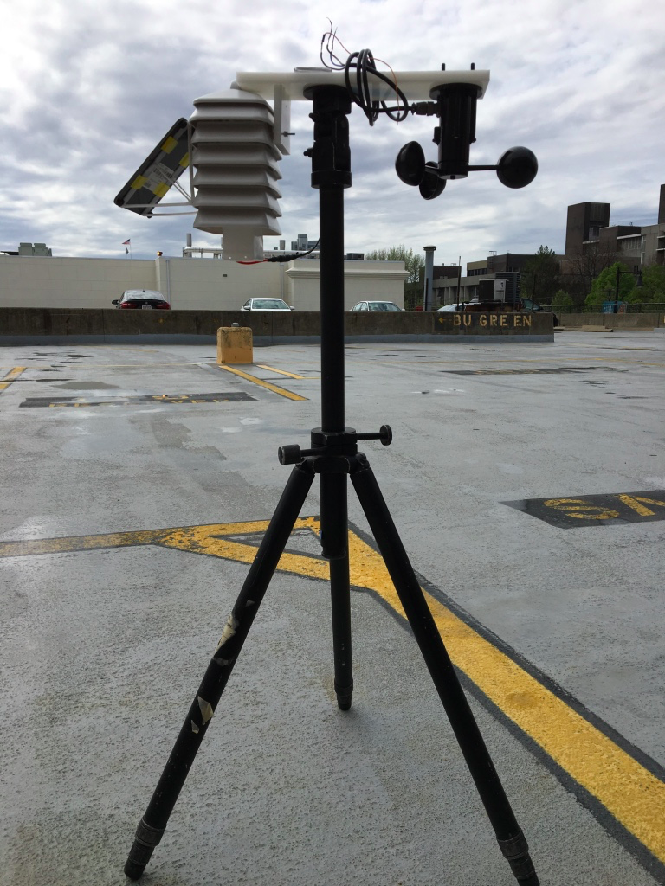

*Figure 1: Full weather station, without the connection of wires*

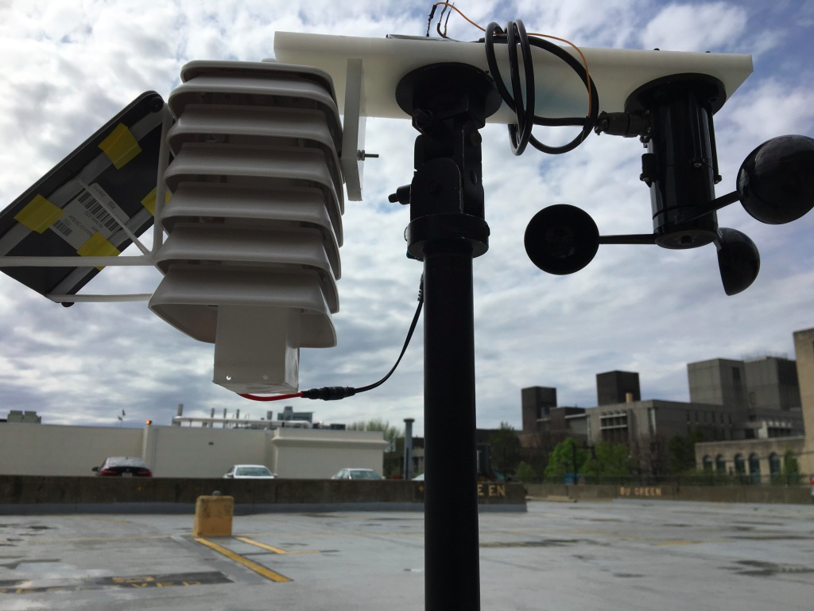

*Figure 2: Close up of the weather station on the roof*

**Functional Architecture** 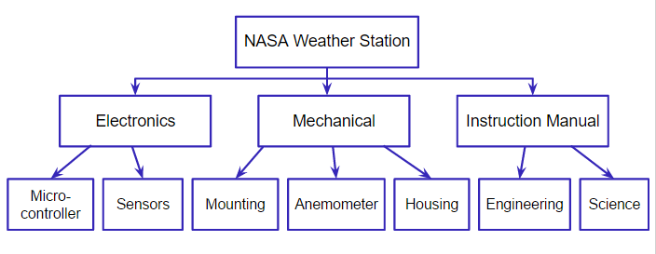

*Figure 3: Functional Architecture of the entire weather station kit*

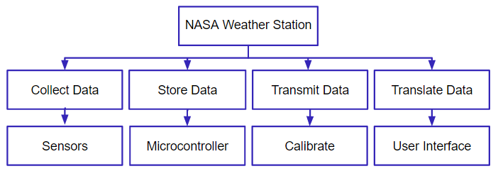

*Figure 4: Functional Architecture of the electronic components of the project (Linear display from data collection to GLOBE)*

This project has several components (see **Figure 3)**; the electrical, mechanical and instruction manual. The electrical aspects of the project encompass the microcontroller and sensors (both anemometer and breakout board sensor), and some components of the “homemade” anemometer. This is further broken down in **Figure 4**, a functional breakdown of the electronics. Weather data(temperature, pressure, humidity, wind speed) is collected by the sensors, then stored in the ESP8266 (the Wi-Fi enabled microcontroller). It is calibrated and sent to a visual data analytics UI software on a computer in real time.

The mechanical components of the weather station kit include the housing, mounting, and the homemade anemometer. The housing shields the sensors and electronics from rain, and outdoor conditions, while keeping them inside the radiation shield. The mounting holds the electrical components to the tripod, and the tripod to the roof.

The last piece of the puzzle is the instruction manual. This is arguably the most important function of the kit because it allows the students to build and understand the kit while learning important science and engineering skills. The scientific aspects of the kit focus on the importance of the weather data gathered by the station, and what GLOBE is using that data for. The engineering side includes step-by-step instructions for building and assembling the kit, as well as explaining how the sensors and other components in the kit work. In the process, students will discover how microcontrollers work, beginner Arduino coding, basic breadboard wiring and connections, how sensors work, how to take accurate measurements, how to build structures from real engineering drawings, and how to use tools safely.

**Functional Decomposition**

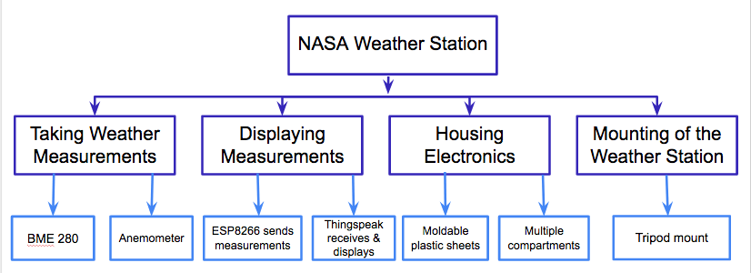

*Figure 5. Functional Decomposition of the Weather Station*

As seen in **Figure 5**, our weather station has the following functions: taking weather measurements, displaying measurements, housing the electronics component, and mounting the entire weather station.

The primary function of our product is taking weather measurements, accomplished with two main sensors. First is a combined sensor to collect data for temperature, humidity and barometric pressure, the BME 280. The other sensor used to complete the function is the anemometer to collect wind speed data.

The secondary function of our product will be displaying the measurements, which is done by two systems. The first system is ESP8266, which serves as our primary microcontroller and that helps our system send out the measurements to our API, ThingSpeak. The second system is ThingSpeak, which is our primary user interface and that helps us receive and display data on the internet.

The third function is to house the electronics and provide a form of weatherproofing our product.. The means in which this function can be completed are with, moldable plastic sheets and a compact design. The moldable plastic sheets were used as the material, because of its ease of use. All students would have to do is heat up the plastic in pieces to create a box. This box is then placed within a radiation shield, which further protects the electronics from direct sunlight. Then referring back to the design, we’ve included multiple compartments with our box for ventilation and water prevention. This will allow the sensor to collect the necessary data, while staying protected from water.

The last function of the product the mounting of the weather station. This is accomplished by using a camera tripod mount. Our mount is meant to ease the placement of our product on roofs of schools. Most camera tripods include a ¼ - 20 screw that allows for mounting. Its meant to lift our electronic high enough off a surface.

**Operation of Mechanisms**

This section is comprised of the electronics, user interface, housing. and mounting, and anemometer portions of the weather station.

1. **Electronics**

What distinguishes our instructable project is the short list of electronics that exist within our system and allows it to work. As for the components within the radiation shield, these include the the BME280 sensor, ESP8266 Huzzah wifi microcontroller, the power boost, and the solar/battery charger board. Finally, located outside the weather station but still connected to the electronics system, the anemometer is another electronics component. In the next few paragraphs I will describe each of the components.

First I will begin with the BME 280 sensor, made by a manufacturer called Bosch, it is a low-cost sensing solution for measuring humidity with ±3% accuracy, barometric pressure with ±1 hPa absolute accuracy, and temperature with ±1.0°C accuracy. This sensor can operate with a main supply voltage of 1.71V to 3.6 V. A full data sheet can be found with this link <https://cdn-shop.adafruit.com/datasheets/BST-BME280_DS001-10.pdf> . This sensor combined almost all of our desired measurables with the exception of wind speed. This sensor is directly connected to the ESP8266, providing an I2C connection.

*Figure 6: Pictorial representation of a sensor*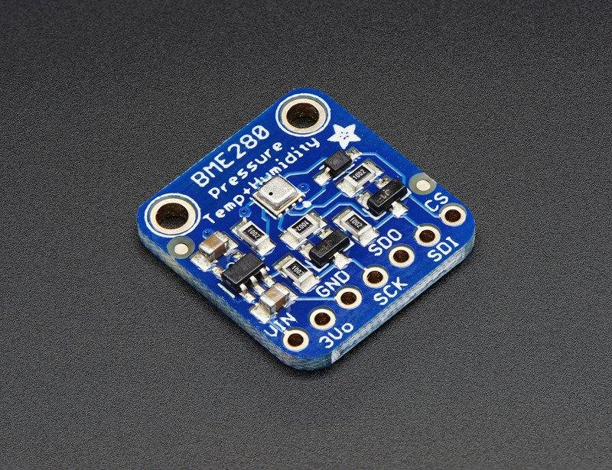

Next up we have the ESP8266 Huzzah wifi microcontroller. This component really help us moving forward, in terms of the amount of space our electronics would take up. It eliminated the need for an arduino and an arduino wifi shield, both of which costs roughly $33. It is an 80 MHz microcontroller with full wifi capabilities drawing an estimated 250 mA. This was a great addition to our electronics list because it works on the Arduino IDE. A full data sheet for this component can be found with this link:

<https://cdn-shop.adafruit.com/datasheets/ESP8266_Specifications_English.pdf> .

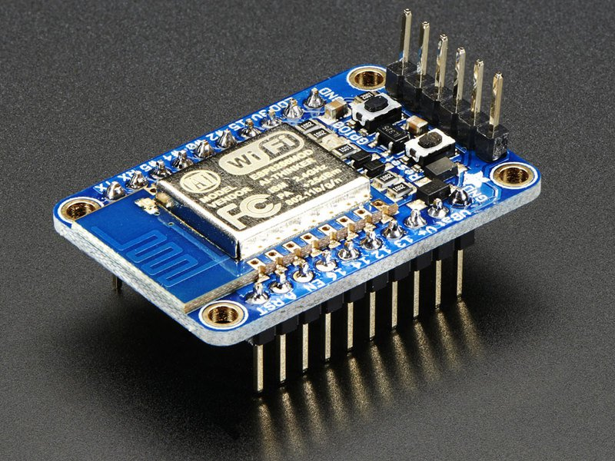

*Figure 7: Pictorial representation of ESP8266 Huzzah!*

Next up, what is helping power our electronics indirectly, is the power boost. It is a DC/DC boost converter module and can run from 1.8V batteries or higher, and convert that voltage to 5.2V DC. Since we are using a 3.7V lithium Ion battery, the power boost supplies at least 2000mA while increasing the voltage to 5.2V. Our product needs this much voltage because the anemometer was tested with a minimum of 5V and it worked. A datasheet can be found with this link

<https://cdn-shop.adafruit.com/datasheets/tps61030.pdf> .

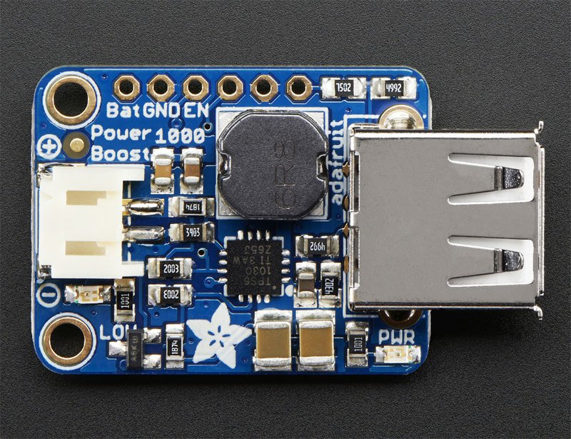

*Figure 8: Pictorial Representation of Power Boost 1000*

Finally what is left within the box of electronics is the solar lithium ion/polymer charger. The charger is meant for 3.7V/4.2V Lithium Ion battery and works well 5-6 DC solar panels. Thus we are using the 3.7V battery and a 6V at 330 mA solar panel. It is set for a max of 500mA max charge rate and will always draw the most amount of current from the solar cell. A key component in this component is the smart load sharing, which automatically uses the input power. A datasheet can be found with the following link <https://cdn-shop.adafruit.com/datasheets/MCP73871.pdf> .

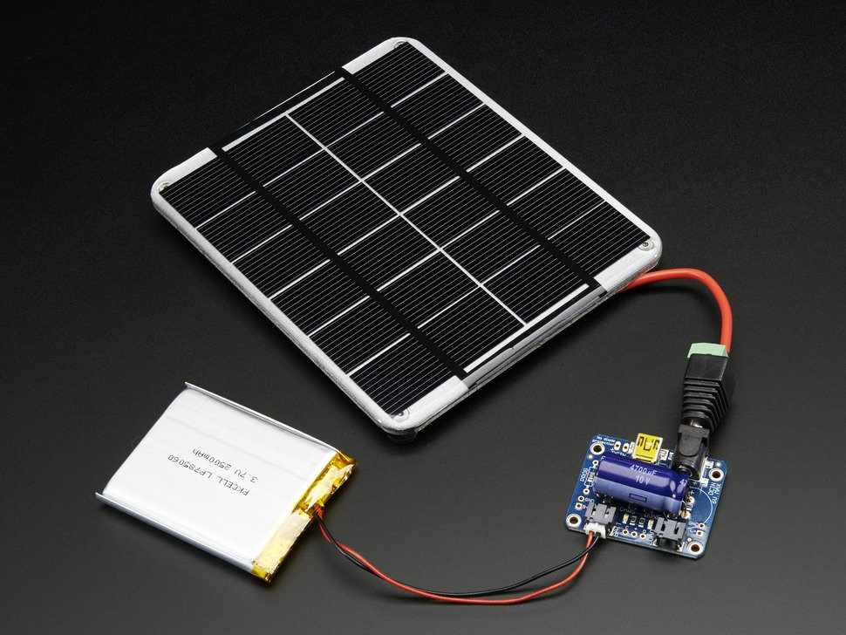

*Figure 9: Pictorial Representation of a solar panel connected to a rechargeable battery*

Then our last electronic component to mention is the Adafruit bought anemometer. To use, connect all that needs to be done is to connect the power and signal ground, and provid between 7-24 Volts but we used 5V with success. Then to get a reading the analog voltage from the blue wire is measured. Specifications state that the voltage will range from 0.4V (0 m/s wind) up to 2.0V (for 32.4m/s wind speed).

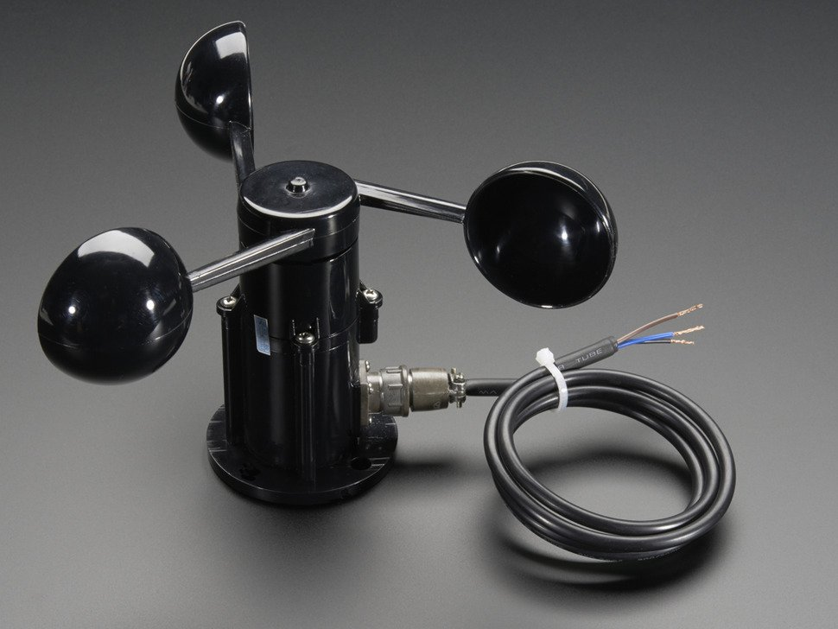

*Figure 10: Pictorial Representation of store bought anemometer*

The system hardware is laid out as follows:

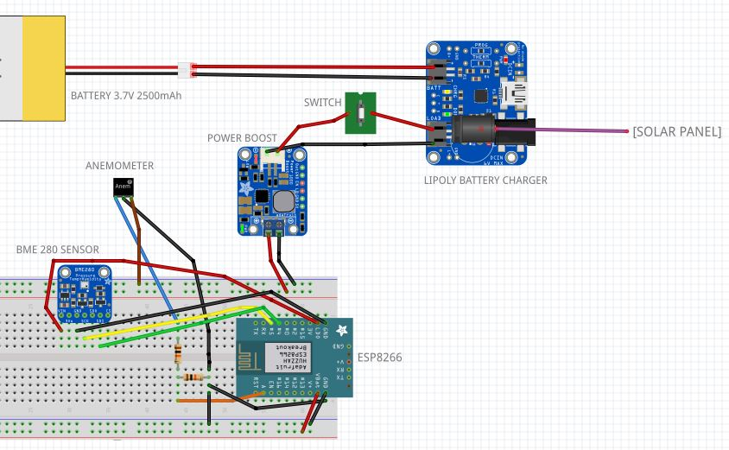

*Figure 11: Schematic of the Electronics Component*

The anemometer maximum voltage output is 2V, while the maximum input to the ESP8266 is 1V. A voltage divider was integrated between in reference to ground to cut the voltage down. Each resistor is 10k $Ω$**.** The ESP8266 is connected to both the BME280 and the anemometer for data upload via Arduino IDE code. The power boost brings the 3.7V battery up to 5V for the Anemometer input to produce a good signal. A switch is integrated between the lithium ion battery charger and the power boost and is accessible from the outside of the housing, to turn the system off and on without opening the entire electronics housing. The solar panel, not shown here, is 6V.

*Figure 12: Picture of the Electronics Component inside Housing*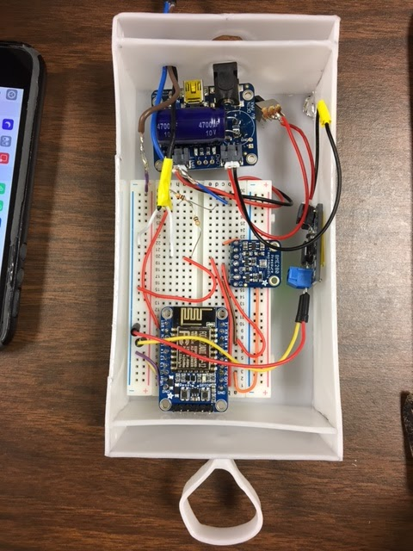

**B. User Interface**

ThingSpeak is an open data platform that allowed us to upload data via wifi with the API, application program interface. Data can be kept private or be made public through ThingSpeak. This platform was helpful in showing the results from our sensors without the need of the serial monitor within Arduino IDE. Our code updates four channels with four unique APIs at once to allow easy data uploading, this data being temperature, humidity, pressure, and winds speed.

**C. Housing**

The electronics housing will need to be the right size to fit all of the main electrical components, such as the ESP8266, the BME 280 sensor, and the breadboard. Ultimately, the housing was created using a custom container made with heat-moldable plastic that high schoolers can shape themselves, prioritizing ease of fabrication and applied educational design thinking. The housing was built by first measuring the dimensions of the inside of the radiation shield. Once the dimensions of the inner box were determined, each side was cut out of the moldable plastic sheets. The edges of the pieces were heated up to a semi-translucent color, and then hold them together to attach the pieces. On the top and bottom of the box, there were two compartments created to prevent moisture from building up on the electronics, which were housed in the center. On the bottom of the box, there were two holes (into the compartment, and then through to the center section) that were drilled to create a ¼-20 hole for the wires. The outer hole was then sealed by heating up and attaching more plastic to close the gaps around the wires. On the sides at the top and bottom of the box, four holes were drilled using a 29 drillbit, to allow for ventilation. Refer to the CAD designs in the **Appendix H** for placement of the holes.

The finished box then had a hook created using the moldable plastic sheets. A thin piece of plastic, a 0.4” by 4” rectangle, was cut out of the sheet to use the create the hook. The plastic was heated up to create a circle, and the edges were heated and sealed together.

A more detailed description (step by step) can be found in the instruction manual.

**D. Mounting**

There are a few components to the mounting of the product. The main feature, a tripod, has a ¼-20 screw at the top, so the main structure was designed around that. A 3” by 12” rectangular piece of HDPE was cut using a hand saw, and there were seven holes drilled into it. In the center, a ¼-20 hole was tapped to attach to the tripod base. On one side there is four ¼-20 holes to attach the anemometer, and finally two 4-40 holes were drilled on the other side to attach the radiation shield. On that same side, into the edge, another ¼-20 hole was drilled also to attach the radiation shield from another area, to limit degrees of freedom and provide a more sturdy mount. Again, refer to the CAD drawings in **Appendix H** for more precise locations. Two different parts were attached to the radiation shield. A ¼-20 screw was put through the top hook of the shield, and the then threaded into the side hole on the HDPE using a hand drill. Then to attach the back hook, a 3” by 3” piece of HDPE was cut using a hand saw. There were two 4-40 holes drilled into the top of that piece, and then was attached to the HDPE using 4-40 screws. 2” from the top of the small piece of HDPE, another 4-40 hole was drilled through the plastic. A 4-40 screw was then threaded into it, and the back hook of the radiation shield was hung off it.

Finally, the last portion of the mounting is to obtain three large buckets, with lids, and fill them with sand or wet cement. Then, each tripod leg would be stuck into a bucket, and a hole drilled into the lid of the bucket to allow the leg to go through. This would create a weighted base to prevent the tripod from falling over.

**E. Anemometer**

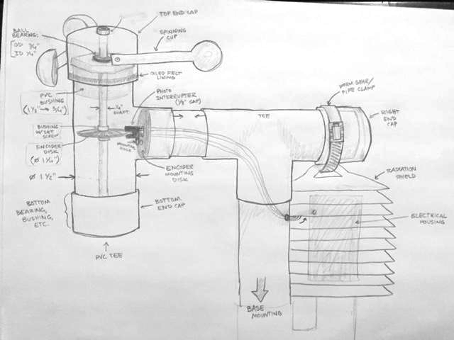

*Figure 13. Current design for the FS anemometer. The photointerrupter mount differs from this picture, as it was improved upon in later iterations.*

Due to the DIY nature, material limitations, cost restrictions, and limited tooling accessibility of this project in a public school system setting, several different options are given in the instruction manual for construction techniques and tools. Many components were purchased off the shelf to be integrated into the custom housing and electronics, including the purchased anemometer. Because of the minimal level of curricular complexity involved in connecting the purchased anemometer’s three wires to ground, power and the ESP8266, a built “from scratch” anemometer (FS anemometer) was designed and tested. This was a very iterative process; for iterations and design decisions, see Section V. The final design has three main functional components; the physical mechanism, the electronics design and hardware integration, and the software (custom Arduino IDE code) and lab calibration.

E (i). Encoder

The heart of the FS anemometer is the encoder. The encoder was designed as a simple but functional 48-slit incremental rotary encoder. The number of “slits” (actually printed bars; for more information about encoder and electrical fabrication, see Part 6 of the instruction manual) was chosen by considering the physical limits of the system; this includes, firstly, the upper limits of the photointerrupter sensing resolution. However, this upper limit is of no consequence, because the encoder resolution is has a smaller upper limit brought about by the limitations of the Arduino IDE software and Serial Monitor. The maximum frequency at which the analog output is read by the microcontroller and output into the Serial Monitor is 1 millisecond. This means that if the encoder is spinning at faster than 0.131 rad/ms, or one revolution in 48 ms, the microcontroller will skip data samples, and some of the photointerrupter output will change before it is read in as an analog output. Bigger and fewer slits would allow for a 

|  |
| --- |
| *Figure 14. The encoder wheel.* |

higher relative accuracy at high wind speeds, but some accuracy would have to be sacrificed. This is because the current angular position range would increase. Currently with 48 slits, one can know the position of the shaft within a range of $±$ 7.5 degrees (in other words, the shaft could be anywhere within the slit width). This is a very reasonable range for our purposes, because it is not position we want information about, but frequency of HIGH and LOW outputs from the photointerrupter. This means that for a given time, the only ambiguity is in the last 7.5 degrees, or one more or fewer HIGH points in the total count per time frame. The current design gives fairly accurate wind speeds for low wind, but uncertainties increase with fewer slits. For the FS anemometer to reach the same maximum recommended speeds as the purchased anemometer, the encoder would have to have fewer slits.

The other integral part of the encoder is the photointerrupter. It is composed of an infrared emitter on one side, and a shielded infrared detector on the other side. When an object passes between the emitter and detector, the beam is broken and the sensor outputs LOW. When the gap is free and the beam unbroken (the white slice of the encoder wheel) the output reads HIGH. While this is an analog output, the values read from the Serial Monitor will be higher or lower. Ours outputs a max value around 980 at HIGH, and a minimum ranging from 100 to 600 at LOW. The exact output ranges depend on the breadboard resistor values; we found that a 1K resistor works well for R2 (high enough to prevent overheating, and low enough to output a reasonable analog range. A 10K $Ω$ weak pull down resistor as R1 to pull the output down to LOW when there is no current. The R1 resistor value was chosen to be relatively large, but small enough to avoid impeding the signal HIGH value. The photointerrupter works like an NPN transistor; when the beam between emitter and receiver is not blocked, current flows through the pullup resistor to ground (LOW). When the beam is blocked, no current flows (HIGH). 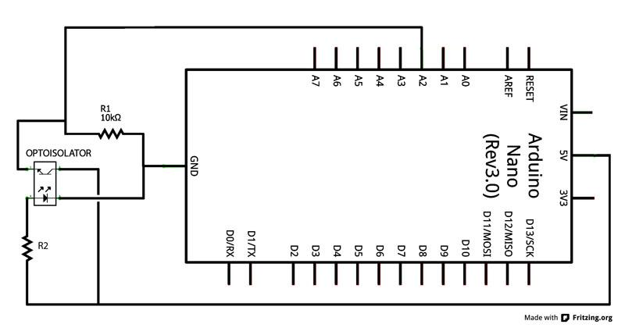

*Figure 15:. The circuit schematic for the photointerrupter and arduino.*

E (ii). Mechanical

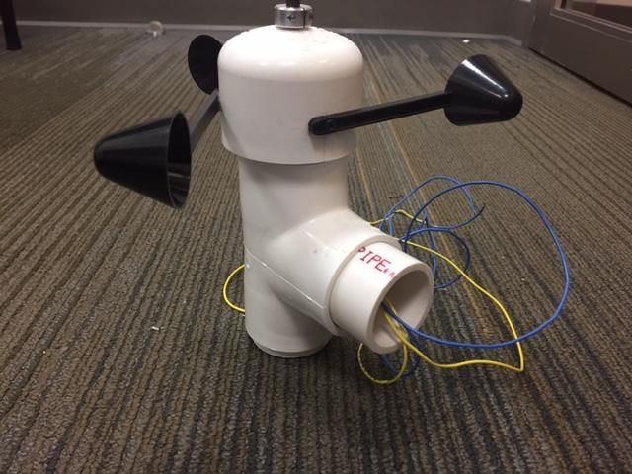

*Figure 16. The FS Anemometer.*

Many measurements and logistics were worked out in adjusting for fits of various structural components (see **Appendix H**). The final design uses PVC pipe fittings as the primary encapsulating structure, which functions as both a shield from weather conditions, and a structural mount for the sealed, lubricated ball bearing. While some of the processes involved in construction are more complex than other subsystems of the weather station (see instruction manual Section 6), it is very doable with adult supervision and the right tools. The design utilizes components easily purchased or found, with a lot of room for alternative design options, based on the resources of the school. For example, coffee scoops were used as anemometer cups, and carefully selected from an online vendor so that they are the right size, sturdy enough to withstand harsh weather conditions, and at the same time thin enough to drill into the handles, which screw into the top PVC end cap. The handles are long to get maximum torque (however, optimal cups found have a smaller cross sectional area than preferred for maximum force on the cups). The rotary structure (which includes the 2” PVC endcap, aluminum shaft, shaft clamps, and encoder) is held by a small ball bearing press fit into a small bit of PVC, which is then fit into a PVC bushing that fits into the main 1.5” PVC tee. These multiple fits were required to match the commercially available bearing diameter with the pipe it fits into (refer to **Appendix H** for fit measurements). The encoder is attached to the aluminum shaft (chosen to be lightweight) with 1/4 “ O-rings that slide snugly onto either side. The 2” cap is attached with small aluminum shaft clamps on either side, and glued into the drilled hole. Finally, a mount was designed to attach the photo interrupter to the inside of the PVC pipe. Because the rounded surface, it was best to mount it to the edge of the 1.5” PVC that fits into the tee. This was made structurally sound, despite the small mounting surface area, by the ridge incorporated into the inside of the PVC tee where the pipe usually inserts and sits flush against it. Instead, the mount, screwed onto the edge, is flush against the ridge, held vertical and sturdy between the PVC pipe edge and the tee ridge. When the entire structure is glued together with PVC cement, this provides a surprisingly simple and sturdy mounting solution.

E (iii). Calibration and Software

The FS anemometer output, random analog numbers spit out from the photointerrupter, are meaningless without calibration. The device was calibrated in a wind tunnel at incremented wind speeds, and the analog output was copied from the Serial Monitor. A custom mount had to be machined so that the anemometer could be mounted inside the wind tunnel, with a fabric gasket between the FS anemometer base and the acrylic mount to accommodate for the bumpy base surface. Structurally, it held up well in the wind tunnel. Because of the higher shaft torque as compared to the purchased anemometer, the lower bound for wind measurements, or the wind speed at which the rotary system started to spin, was about twice that of the rated minimum speed in the purchased anemometer specs sheet (0.5 m/s, compared to the 1.04 m/s started speed of the FS anemometer). The calibration curve is fairly linear, and a first-order calibration equation was derived from the plot:

$y = 0.03x + 0.6622$

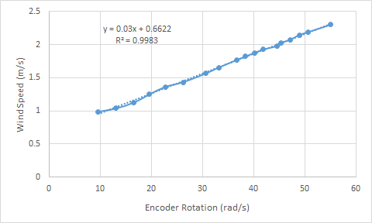

*Figure 17: Anemometer Calibration*

In which y is wind speed in m/s, and x is anemometer rotation speed in rad/s.

In the graph, each point was found by counting the number of HIGH points in a 300 ms time frame taken from the data for each wind tunnel frequency and wind speed. The rotation in rad/s was calculated from number of HIGH points. The wind tunnel speed was calculated using Bernoulli’s laws, taking pressure readings from the manometer at each frequency (see **Appendix E**).

E (iv). Alternative Construction Processes

Because the instruction manual was the main project deliverable, not only the final physical product, but the construction process was also designed as a part of the end product manual. Therefore, the rest of this section will outline alternative processes designed with the customer in mind. The rest of the construction, when completed in a standard way, is described in detail in the instruction manual.

In addition to the basic construction methods, the instruction manual accommodates for limited access to common machine shop tools; in Section 6, a method is developed for press-fitting the bearing into the PVC with a small table clamp, rather than utilizing the commonly used Arbor press in a machine shop), and alternatively by utilizing thermal expansion and contraction (sticking the bearing in a freezer for an hour is a fairly accessible method).

The encoder wheel was not purchased, because the steep price meant increasing the total weather station cost, and decreasing accessibility of this portion of the project. Instead, a custom encoder wheel was designed in a graphics software and printed at FedEx on a thick, clear projection sheet for 50 cents. The wheel image is open-source and available in the manual.

Creating threads for screws to mount the cups and photointerrupter mount also posed an issue; while assuming that high schools will have basic tool kits, this will probably not include threading bits and hand taps. To accommodate, self-threading screws are included in the BOM, as well as methods to pre-drill holes and then twist in the screw with a screwdriver or hand drill into the soft PVC plastic.

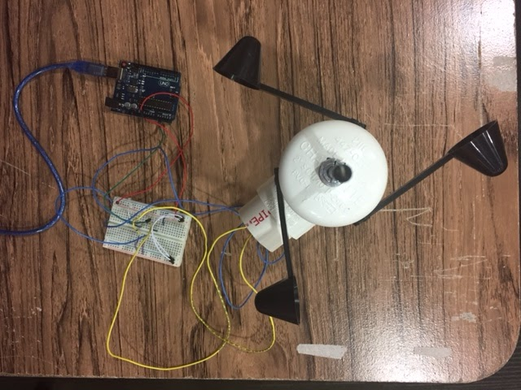

*Figure 18. The FS Anemometer with electrical components.*

**How to Use our Instruction Manual**

Please refer to the instruction Manual Section 1, subsections “How to Use this Manual” and “Ratings and Info Boxes Explained” for detailed description of how the manual is organized and how it works. Refer here also for detailed information about construction, maintenance, and general weather station use. It is attached to this report (if in physical form) or available for download.

DESIGN DECISIONS

The following is a chronological walk-through of each design step of each weather station component, including all notable design decisions and incremental iterations. This part is separated into the following sections: sensors, power supply, wifi connectivity, housing, mounting, anemometer, and instruction manual.

**Sensors**

One of the main restriction on sensor selection came from the meeting the GLOBE requirement to specifications for the measurables, as seen in **Appendix I.** Based on those specifications, we chose to use a BME 280, which is an environmental sensor that combines temperature, barometric pressure and humidity into one chip. This helped us save space in our electronics housing portion. All the sensors were preliminarily tested, found, and purchased on Adafruit, an open-source hardware company. The combined sensor had the same accuracy as separate sensors so it made the whole system more condensed and simple. Using the BME 280 sensor, we went on and established a wiring schematic and integrated the sensor for the breadboard components. An Arduino IDE code was written, found, and compiled for timed sensor data collection.

Preliminary testing included going indoors and outdoors to see the effect of wind. It was found to have a large impact on our system. When collecting sensor data every second (outside at 6º C), a sudden gust of wind dropped the reading by a whole degree. Therefore, we tested the accuracy of sensors by comparing the measured values to known values. It was found that the the accuracy of the tested sensor is said to be +/- 1 ºC between -40 ºC and 80 ºC. During testing its was 7 ºC outside and our sensor reached steady state at 7.56 ºC. These findings were then noted in the instructions manual.

In regards for the other sensors, we eliminated the precipitation measureable because of cost (an additional $100-$150) and due to a lack of customer interest. The most important measurable we considered was the anemometer. In finding the perfect anemometer, we created various pugh charts, as seen in **Appendix B.** A couple possibilities included connecting a pre-purchased anemometer to the rest of the system and building a handmade anemometer from scratch by integrating a photointerrupter and encoder wheel to detect wind speed from frequency of output signal peaks when the shaft rotates.

There were two anemometers used in this project, based on our Pugh chart comparison two had the same value seen in **Appendix B.**. A $55 anemometer purchased from Adafruit. The alternative was the hand built anemometer, which would lower the costs and introduce principles of electromechanical design to high school students. The data from the hand made anemometer would not be sent to GLOBE because it would not meet GLOBE requirements.

For the hand-built anemometer, our team tried preliminary testing on a motor-generator (a small DC brushed PM motor) with an Arduino controlling a 5V DC motor and reversing the code and circuit. We ultimately decided against this anemometer method because it would require a minimum wind speed to provide the torque necessary to turn the motor shaft. It is also a more indirect method of measuring wind speed and it may output less than optimal results without a gear reducer, which brings in mounting and cost complexities.

An encoder was chosen to measure the wind speed of the weather station because it is non-contact (no shaft torque to overcome), smaller and lightweight, and vastly cheaper than other alternatives. Making the encoder from scratch was deemed a better option than the available Arduino kit encoder. This includes using a purchased photo interrupter in conjunction with an encoder wheel, easily made from a clear acrylic disk with blacked out radial sections. This is preferred because the Arduino encoder is designed to be turned by hand, attaching the bearing shaft end to the end of the Arduino encoder knob would be difficult, and photo interrupters are very cheap, and the encoder wheel is simple to make. A ball bearing was chosen to minimize friction in cup rotation. It must be sealed for outdoor use, and pre-lubricated for minimum maintenance.

Ultimately, we decided to focus on the integrating the store bought anemometer with the system. We felt it would be most beneficial to high schools without machine shops and many hand tools to have a pre- built option. Most high schools will not have intensive electrical engineering courses either, so using a pre-built anemometer would be a simpler option for them to understand, and still gets the same data. Since the store bought anemometer is already combined and calibrated, all the high school students would be required to do is connect it to the ESP 8266 and it is already combined in the code. This makes it very easy to add to the weather station, if the school wants a less intensive option.

**Power Supply**

As previously mentioned in the customer requirements, the power supply must be self powered and rechargeable. Our options included solar panel and battery, and a mini wind turbine possibly integrated with anemometer. We chose to use a solar panel was chosen over a small turbine because It requires fewer components, easy to integrate with the rest of the system, and it is smaller and more portable. Coupled with the fact that solar panels are exciting and appealing to people of all ages, the solar panel was our choice. The solar panel board was also chosen because of its load sharing. When it is placed in direct sunlight, it will skip charging the battery and directly power the wifi shield. However, we had to consider the possibility of overheating from continuous charging and discharging of battery is a remaining possible issue.

For the power supply, we chose to use a a solar panel with a rechargeable battery because it required fewer components, integrated easier with the rest of the system, and it is smaller and more portable. Coupled with the fact that solar panels are exciting and appealing to people of all ages, the solar panel was our choice. The solar panel board was also chosen because of its load sharing. When it is placed in direct sunlight, it will skip charging the battery and directly power the wifi shield. A switch was placed later on to turn collecting data on and off.

**Wi-Fi Connectivity**

Another important component of our design was figuring out how to connect our system to wifi. The ESP8266 microcontroller was chosen for use in the system over the Arduino wifi shield. This was because it is considerably cheaper than a wifi shield, it eliminates the need for the Arduino itself, since the ESP8266 is also a programmable microcontroller, it has the same functions as the wifi shield and is compatible with the Arduino IDE. Altogether, this saves around $60 in costs.

Arduino was eliminated from the BOM, deemed unnecessary because of integration of the ESP8266 microcontroller. Arduino IDE code was created to connect to the hotspot wifi network, and this code was integrated with the sensor data collection code (see **Appendix F**).

Initially the user interface the data was going to was GLOBE, but due to GLOBE’S restructuring their data reception system (used to be email), a different user interface was used. Initially the station was going to send emails to GLOBE for the data receptions, but due to the restructuring a different platform was chosen. An online database called Thingspeak, which uses application program interface (API) to receive data, which is the same method GLOBE is shifting to. Thingspeak is a very useful database because it is very accessible to the public, it is easy to use and understand, and displays the data graphically in real time which is very exciting and educational for students.

**Housing**

Another important aspect of the weather station was consider how to protect and house all the electronics components. The electronics housing will need to be the right size to fit all of the main electrical components, such as the ESP8266, the BME 280 sensor, and the breadboard. Going off of the requirements from the previous sections, the group had to consider many possibilities. The overall system needs to account for air circulation for the sensors in order to prevent overheating and excessive moisture that may affect the temperature and humidity readings. The system also needed to be waterproof in order to prevent water damage from rain as well as moisture, while keeping housing open for ventilation.

Initial housing and container designs to lodge inside the radiation shield included a mesh steel or aluminum cage with holes smaller that 0.1 m in diameter to achieve RF shielding. This helps prioritize RF shielding, ventilation and data accuracy. Another design featured a tupperware container with enough holes drilled through it to allow ventilation and wires running in and out of it. This helps prioritize ease of fabrication in a high school environment. Other alternatives included utilizing a 3D printer, but these were quickly thrown out due to a high school’s lack of a 3D printer. Ultimately, the housing was created using a custom container made with heat-moldable plastic that high schoolers can shape themselves, prioritizing ease of fabrication and applied educational design thinking.

Originally, initial thoughts and advice recommended that this housing be made out of metal to take into consideration the Faraday effect and prevent other electromagnetic waves from interfering with wifi connecting and distorting the data. However, a data sample was taken and the signal to noise ratio (SNR) was found **Appendix C**, and the SNR was high enough that there is no significant disruption.

Electronics housing design remains a topic of discussion. Future concerns revolve around overall wiring of the station. Wires must connect the inner electrical components of the anemometer down a length of PVC to the breadboard, and the solar panel mounted on the outside of the radiation shield must be wired to the breadboard as well, with structural PVC housing designed to prevent significant wire exposure to the elements or risk of damage. Additionally, future iterations will include a design to easily open the housing container for electrical maintenance, instead of heat sealing the plastic cover over the top. This would incorporate a rubber gasket to maintain a watertight design, in between the lid and edges of the box. The lid would be pressed shut with a clip hinge.

**Mounting**

There were several mounting decisions made throughout the process. Due to the tool limitations, we chose to use Marine-grade HDPE as our main mounting material because it is soft enough to cut through with a hand saw, and to thread with a drill and a screw. We chose to utilize both the hooks on the radiation shield to secure it to the tripod mount, because just using one allowed the shield to move with the wind which is undesirable. The tripod mount was chosen as the main mount structure because it is cheap, easily accessible and provides the required height and stability without any machining. This makes it easy to install on high school roofs. We chose to mount the anemometer on the top of the structure to get the least shielding from wind.

Finally, the last mounting portion is to give it a weighted base to prevent the whole system from falling over from other weather related issues. To tackle this issue, the tripod legs will be placed in buckets of wet cement or sand. These buckets will have lids to prevent any weather deterioration that have holes just large enough for the legs to fit through. Cement and sand were chosen as options to fill the buckets because they provide weight to support the structure, and are more easily accessible for high schools.

**From-Scratch (FS) Anemometer**

There were many different ways to engineer a device that can measure rotation speed. The two designs considered for the lengthiest amount of time was the encoder (the final design prototype), and running a small brushed DC motor backward as a generator. This second option will be described briefly first.

Using a small DC motor was originally the chosen mechanism for this measureable. The motor shaft would be connected to the anemometer cups, and the wind would sin the shaft, generating a voltage output corresponding with wind speed. This was an easy design in terms of structure, as the “cap” of the anemometer is simply the motor shaft, and no extra mounting designs or rotational mechanisms (bearings fits, cup mounts on a rotating structure, etc) would be necessary. Additionally, the output directly correlate to a wind speed, while the encoder would require additional calculations and analog output peak frequency analysis. However, the DC motor was ultimately decided against for several reasons. First, the motor shaft torque was deemed too high to measure wind speed. While it wouldn’t prevent an accurate calibration, the minimum wind speed required for a voltage output and reading would simply be much too high. In comparison, the encoder design uses a bearing, which greatly reduced friction and allows for smooth rotation. Secondly, the DC motor is much more expensive than the encoder and photointerrupter. See **Appendix B** for other options considered in the FS Anemometer design process.

**Instructional Manual**

There were many components to consider about the educational resource, the main deliverable of the project. There are a few main things the team wanted student to take away from the instruction manual. These include the technical engineering skills involved in fabrication, contextual knowledge about weather systems, the natural environment, and scientific phenomena associated with our measurables, and lastly, research skills (including technical drawing reading, website searching, using the internet as a resource and to debug, etc.) highly useful in everyday life, and an essential part of any career in STEM.

The manual was split into six sections for easy understanding and breakdown of subsystems. In each section, the flow of information usually flows in this order: background information, tools and materials, construction, and debugging. It was decided to include the FS anemometer in the instruction manual despite its incomplete integration with the rest of the system, as its optional construction would still provide an excellent learning experience for students. With the variety of skills and engineering involved (electrical, software, and mechanical) and exceptionally detailed technical descriptions, we hope it provides students with a wide range of skills to enter college or a technical career with.

Secondly, it was decided that scientific context for the project was worthwhile and important, both as motivation and useful information. It also fosters an appreciation for the environment and for a topic that many people their age only associate with dull channels on TV (the weather channel). We included this information as external links and resources in our instruction manual to encourage a high school curriculum in which scientific environmental background precedes the technical fabrication process.

Lastly, we hope that our instruction manual is not the only resource students go to. Because research skills are valuable, and due to the limited scope of this project, it was decided to reference many skillsets required (how to solder, additional Arduino background information, how a breadboard works, the science behind temperature, pressure and humidity) with links to additional information. For example, knowing that there were great educational resources in the GLOBE website, we used the majority of the site to help educate the students on the science behind our measurables. Many of the resources are also open source, for either ease of online access to tools (like our Arduino IDE code posted on Github) or for additional exploration (like our CAD files posted on GrabCAD).

DESIGN EVALUATIONS

**Project Week Evaluation**

Our design evaluations were tested and successfully prototyped with our supplemental customer, Fenway High School. Below is a short summary on our testing.

In preparation for Fenway High School’s annual Project Week, we created a working prototype, educational manuals, and a classroom agenda for ourselves and for the students. We had 12 students and 3 teachers from the high school work with us to showcase our prototype. For this particular prototype, the anemometer was not included for simplicity sake. For the complete agenda, please refer to the **Appendix K.**

The day was designed in two major parts: instructional and hands-on. The morning consisted of presentations on GLOBE, the project and its importance, information on the measurables, as well as an arduino tutorial. The afternoon session consisted of a hands-on component in which the students broke up into groups and built two complete weather stations. The groups are described below.

Instruction manuals were created in three different educational packets: wifi group, sensor group, and housing group.

For the wifi group, 4 students were in charge of using the ESP 6288 Huzzah wifi module, and connecting to a personal hotspot from a cellular device. They had to understand the code and use the program Arduino IDE to implement the scripts.

For the sensor group, 4 students were in charge of using the breakout board sensor with an Arduino Uno and outputting the data into the serial monitor. They also needed to utilize a code in Arduino IDE in order to get the sensor working.

After the wifi and sensor group separately tested the two components, they had to come together and get the sensor data to output to a database website, Thingspeak.com, using the wifi board to wirelessly output the data onto the website. The website was used to visually understand the data collected using the sensor on real time graphs.

For the housing group, 3 students were in charge of designing, creating, and executing a housing mechanism for the entire structure. In order to design the system, students had to consider the constraints and brainstorm out of the box. Skills that were utilized included geometry, measuring, and considering the tolerancing.

After all the components of our prototype were put together, there were 2 complete weather stations. The students then took the prototype outside to collect temperature, humidity, and pressure data, and see how the graphs changed outside versus the indoor setting. Once the data was plotted, the students were generally impressed by their creation and by the change in data. A survey was given at the end of the day to evaluate the success of the activities, and the feedback received will be utilized for the final product.

Overall the whole day was a success. The surveys indicate that the students were generally more interested in STEM after the whole day, and the students genuinely enjoyed the second half of the day’s activities. Actually building the weather station peaked the student’s interests, and almost all of them were actively engaged in the part they were responsible for. Future considerations include revising the educational resources and reading through the student surveys and implementing their suggestions into our package.

**Technical Design Evaluations**

Technical design evaluations were also performed. First, a test was required to determine if electromagnetic shielding would be necessary in our housing design; this would determine which kind of material would be necessary in housing. Ultimately, it was seen that RF shielding would not be necessary, getting rid of the need for a metal structure and making it easier to design a housing easily constructed at a high school level. See **Appendix C/D** for test details and data.

Secondly, several technical limitations in the FS anemometer encoder design were discovered with wind tunnel testing. At 22 Hz wind tunnel setting (about 2.29 m/s or 5.1 MPH), the data started to break down; the analog output’s oscillations were interrupted with missing chunks and shorter peaks (see **Appendix E**). This points to the upper limits of the encoder design (see section E under Design Description); the shaft began spinning too fast for the 1ms Arduino sampling time to pick up every beam interruption from the encoder. This means that we need either a faster sampling time, or fewer encoder slits (at the expense of position accuracy).

VII. MARKET AND COST ANALYSIS

Unlike other mechanical engineering senior design groups, we are not tailored to a customer but to to providing a feasible and working prototype to high school students. All the money used will come from the GLOBE grant that Boston University is currently a part of. The end result of this project is to create an open source code, and provide a instruction manual to the high schools, so this project is non profit and standard financial analysis is not relevant. However, below are some financial factors and tradeoffs that were evaluated.

The main limitation that was faced is the budget allocated to high schools. Most school have a low, fixed budget for the science department so the product would have to be very low cost. When choosing the materials and components to the project, we considered the cost, the ease with which schools could obtain the materials and simplicity of the design. However, due to these budget constrictions, the tradeoffs were complexity of design, aesthetics and size and power of the components. With a higher budget, more tools could be bought to increase the complexity, and more sensors could have been incorporated. Overall, the cost managed to be what a high school would be able to afford while completing the objectives and meeting the customer requirements.

CONCLUSION

Overall, this project was extremely successful. We were able to create a feasible and inexpensive weather station. In fact, the Gutierrez Weather Station is half the price of the Davis Weather Station at a stunning price of $250. Our weather station was able to collect and transmit data similar to GLOBE’s new system. Since GLOBE was moving towards using an application programming interface, we decided to follow suit and utilize our UI design of ThingSpeak to the best of our abilities. Our entire weather station requires absolutely no machining, which makes everything accessible to high school students. The most they need to use is a drill. Thanks to our demonstration with Fenway High School, we had a successful testing while encouraging STEM. We also were able to utilize student surveys and implement them into our design now.

The Gutierrez Weather Station is half the price and twice the fun!

RECOMMENDATIONS

This section is intended to provide a couple of recommendations for future endeavors. First off, finding a way to send data to GLOBE is a top priority. Currently, GLOBE is in the process of restructuring their entire system. Because of this, we were not able to transmit data with GLOBE’s current system. Another thing to consider would be to continue reducing the costs because high school systems have a limited budget. Our project is geared towards any school who has an interest in NASA GLOBE and hand-on weather data collection experience, therefore exploring options for cost reduction in the future is definite.

For the housing portion, a couple key components to add would be to replace our tape attachments with velcro. Velcro will help attach the electronics effortlessly to avoid cluttering and lose components. Adding a layer of insulation with the battery and breadboard to prevent the battery from overheating and therefore affecting the sensor reading. Also, designing a component to allow for easier access to open and remove components is something to think about for the future.

In terms of the structure, one suggestion would be to add an accelerometer to gauge if the station gets knocked down. Lastly, we can screw a hook to the main mounting HDPE slab to hook wires to minimize risk of tangling and element exposure.

For the handmade anemometer, we would integrate software with the rest of the system and develop a structural mount.

EXECUTIVE SUMMARY

The Gutierrez Weather Station is a top of the line product. Built in a culmination of four months, 100+ hours - this is the best iteration that we have. Along with the instruction manual, it is a concise and in-depth weather station manual available online. Our weather station encourages citizen science, which means getting students and the general public to be more involved in science, to gather climate related data while providing NASA with real time data from around the world. The climate science data is gathered from satellites and from ground based data.

Our final weather station is compiled of an electronics component, a mechanical component, and the instruction manual. We were able to create a functional and inexpensive weather station using these components. Altogether, this weather station should have a lifespan of five years. Of course, there will be new iterations and additions to this project as the years come; future groups will need to integrate with GLOBE. Our project is extremely versatile, we have two different anemometers that can used depending on the student’s interest and skill set. ThingSpeak, an internet of things data analytics software, helped us translate the data in an interactive way, and displays data in real-time visualisation.

As mentioned, the Davis Weather Station retails for $400 for the electronics components and $100 for the mounting component.. Our Gutierrez Weather Station retails for $200 for the electronics component while the mounting portion retails for $50. Our product is half the price of our direct competitor and it introduces the educational aspect that allows high school students to experiment and gain knowledge on STEM and engineering related activities. Having the students be able to create and watch a product come to life was one of our main goals. Combine with encouraging citizen science, we achieved our goal of providing lifelong learning to high school students.

As engineers and scientists, we believe furthering citizen science was important in our goal. Not only does our product encourage citizen science, we made our weather station effective and versatile in teaching students. In fact, this was showcased during our Project Week demonstrations. Project Week was a collaboration between Boston University and Fenway High School where our team got to test our our prototype. We were able to successfully build two weather stations from scratch, craft an agenda to run the whole workshop, and create supplemental programming exercises for the students. After the workshop, we had the students complete surveys. Afterwards, we analyzed the surveys and implemented concerns into the final prototype. Overall, our workshops increased the student’s interest in STEM.

We found that there were no alternatives of the same quality that can address numerous measurables. Data analysis is a big portion of our presentation because there is a lack of engineering appreciation and real-world data analysis in schools. We wanted to engage students to contribute meaningfully to our understanding of the Earth system and global environment. The Gutierrez Weather Station is a top of the line product. Included is the most in-depth and accessible weather station manual, this product was extremely successful.

ACKNOWLEDGMENTS

Thank you to the following people --

Professor Enrique Gutierrez-Wing for providing us with your room, materials, advice, ever-lasting wisdom, and for getting us in contact with the right people at the right time. Without you, we would have no project week or workstation to sleep in.

Professor Caleb Farny as our customer for providing us with materials and advice.

Professor Garik as a collaborator and for providing us with GLOBE funds.

Ms. Benadette Manning as our point person in Fenway High School.

Mr. Keith Magni, Mr. Victor Mateas, and Mr. Russell Thompson as the teachers from Fenway High School who we coordinated with during Project Week.

Without the help of our incredible mentors and professors, we could not have completed this project or have had such a rewarding time.

APPENDICES

A. BILL OF MATERIALS

The bill of materials is split into two components: the electronics component and the housing and mounting portion.

Below are the costs for the electronics component for our current weather station.

|  |  |  |
| --- | --- | --- |
| **Item** | **Category** | **Cost** |
| PowerBoost 1000 Basic - 5V USB Boost @ 1000mA from 1.8V+ | Power | $14.95 |
| Lithium Ion Polymer Battery - 3.7v 2500mAh | Battery - Power | $14.95 |
| Adafruit BME280 12C or SPI Temperature Humidity Pressure Sensor | Humidity / Temp / Pressure | $19.95 |
| Adafruit HUZZAH ESP8266 Breakout | Wifi | $9.95 |
| Medium BreadBoard | Board | $5.00 |
| Radiation Shield | Shield from Radiation | $20.70 |
| 3.5 / 1.3mm or 3.8 / 1.1mm to 5.5 / 2.1mm DC Jack Adapter Cable | Solar power | $0.95 |
| USB to TTL Serial Cable - Debug / Console Cable for Raspberry Pi | Wifi | $9.95 |
| JST 2-pin cable | Power | $0.75 |
| Anemometer | Wind speed | $54.06 |
| USB / DC / Solar Lithium Ion/Polymer charger | Breakout board for charging | $17.50 |
| Medium 6V 2W Solar panel | Power | $29.00 |
| Screws: 1/4-20 x 5/8" (5x), 4-40 x 1" (3x), 6-32 x 3/8" (3x) with nuts, 3-48 x 3/8" set screw (1x) | Screws | ~$6.00 |
|  | **TOTAL** | **$197.71** |

Looking at the budget above for the electronics component, the team has currently spent a little below $200 from the overall budget. It is important to note that this budget is for the primary customer, Professor Farny. For the supplemental budget, please refer to **Appendix A.** It is also important to note that the wifi serves as the microcontroller, so that eliminates the need for an arduino. For our electronics component, we were able to create a feasible prototype for half the price of the Davis Weather Station electronics component.

|  |  |  |
| --- | --- | --- |
| **Name of Sensor** | **Category** | **Cost** |
| HDPE (marine grade) | Mounting | $16.61 |
| Tripod | Tripod | $23.50 |
| Darice Multi-Purpose Heat Tool, 320 Watt | Heat Gun | $11.35 |
| Polly Plastics Heat Moldable Plastic Sheets - 3 Sheets, 8 x 12 x 1/16 | Housing | 18.95 |

**Additional BOM items for FS Anemometer**

|  |  |
| --- | --- |
| **Item** | **Cost** |
| PVC pipe (1), tee (2), bushings (3), cap (1) (Home Depot) | $13.18 |
| Thick Walled Unthreaded PVC Pipe | $4.68 |
| PVC Cement and Primer | $9.10 |
| Anodized Aluminum rotary shaft | $11.83 |
| 1/8" Gap Photo Interrupter Slotted Optical Switch | $3.83 |
| Clamping Shaft Collar | $4.40 |
| Thick-Wall PVC Pipe Fitting (Cap) |  |
| Standard-Wall PVC Pipe Fitting (Bushing) | $2.23 |
| Chef Craft 4 Piece Perfect Coffee Measuring Spoon Scoop, Black | $2.00 |
| R4A-2RS Bearing 1/4"x3/4"x9/32" inch Sealed Miniature | $6.80 |
| Thick-Wall PVC Pipe Fitting (Cap) | $5.37 |
| Chef Craft 4 Piece Perfect Coffee Measuring Spoon Scoop, Black | $6.80 |
| R4A-2RS Bearing 1/4"x3/4"x9/32" inch Sealed Miniature | $5.37 |
| Super Glue | $1.88 |
| TOTAL | $47.56 |

**Budget for Fenway High School**

|  |  |  |
| --- | --- | --- |
| **Name of Sensor** | **Category** | **Cost** |
| USB / DC / Solar Lithium Ion/Polymer charger | Breaker board for charging | $17.50 |
| Medium 6V 2W Solar panel | Power | $29 |
| Adafruit BME280 12C or SPI Temperature Humidity Pressure Sensor | Humidity/Temp/Pressure | $19.95 |
| Adafruit HUZZAH ESP8266 Breakout | Wifi | $9.95 |
| Medium BreadBoard | Board | $5.00 |
| Lithium Ion Polymer Battery - 3.7v 2500mAh | Battery - Power | $14.95 |
| 3.5 / 1.3mm or 3.8 / 1.1mm to 5.5 / 2.1mm DC Jack Adapter Cable | Solar power | $0.95 |
| USB to TTL Serial Cable - Debug / Console Cable for Raspberry Pi | Wifi | $9.95 |
| JST 2-pin cable | Power | $1.50 |
| Budget Pack for Arduino (Arduino Uno R3) - Uno w/328 | Arduino | 34.95 |
|  | TOTAL | $108.75 |
|  | Budget left | $291.25 |

**Appendix B: Pugh Charts for Sensors**

B.1 Pugh Chart for Temperature

|  |  |  |  |  |  |  |
| --- | --- | --- | --- | --- | --- | --- |
| **Key Criteria** | **Rating** | **RTD** | **PN Junction Silicon Diode** | **Thermistors** | **Thermocouple** | **Digital Thermometer** |
| Cost | 2 | - | + | + | - | 0 |
| Accuracy | 2 | - | 0 | + | + | 0 |
| Durability | 1 | - | - | - | - | 0 |
| Size | 1 | + | + | + | + | 0 |
| Complexity | 2 | + | - | + | + | 0 |
| Output (digital or manual) | 2 | + | + | + | + | 0 |
| Total |  | **0** | **2** | **8** | **4** | **0** |

B.2 Pugh Chart for Barometric Pressure

|  |  |  |  |  |  |
| --- | --- | --- | --- | --- | --- |
| **Key Criteria** | **Rating** | **Barometer (w/ altitude and temperature)** | **Altimeter** | **Aneroid barometer** | **Barometer (w/ temperature)** |
| Cost | 2 | + | - | 0 | + |
| Accuracy | 2 | + | + | 0 | + |
| Precision | 1 | + | + | 0 | + |
| Durability | 1 | 0 | 0 | 0 | 0 |
| Size | 1 | + | 0 | 0 | + |
| Complexity | 2 | - | 0 | 0 | - |
| Output (digital or manual) | 2 | + | + | 0 | + |
| Total |  | **6** | **2** | **0** | **6** |

B.3 Pugh Chart for Wind Speed

|  |  |  |  |  |
| --- | --- | --- | --- | --- |
| **Key Criteria** | **Encoder** | **Small Motor** | **Anemometer** | **Computer fan** |
| Cost | + | + | 0 | + |
| Accuracy | 0 | 0 | 0 | - |
| Precision | 0 | 0 | 0 | - |
| Durability | 0 | 0 | 0 | 0 |
| Size | + | 0 | 0 | 0 |
| Complexity to build | - | - | 0 | - |
| Ease of integration | 0 | - | 0 | 0 |
| **TOTAL** | **1** | **-1** | **0** | **-2** |

B.4 Pugh Chart for Humidity

|  |  |  |  |
| --- | --- | --- | --- |
| Key Criteria | Sling psychrometer | Digital hygrometer | Temperature & humidity sensor |
| Cost | + | 0 | + |
| Accuracy | - | 0 | + |
| Precision | - | 0 | + |
| Durability | 0 | 0 | 0 |
| Size | - | 0 | + |
| Complexity | + | 0 | 0 |
| Output (digital or manual) | - | 0 | 0 |
| TOTAL | -2 | 0 | 4 |

B.6 Pugh Chart for Precipitation

|  |  |  |  |  |
| --- | --- | --- | --- | --- |
| **Key Criteria** | **Rating** | **Raindrop sensor** | **Tipping spoon (bucket)** | **Rain gauge** |
| Cost | 2 | + | + | 0 |
| Accuracy | 2 | - | - | 0 |
| Durability | 1 | + | - | 0 |
| Size | 1 | + | + | 0 |
| Complexity | 2 | + | - | 0 |
| Output (digital or manual) | 2 | - | - | 0 |
| TOTAL |  | 2 | -4 | 0 |

**Appendix C: SNR Calculations**

$$SNR = 20×{\log_{10}\left(\frac{{\underline{V}}_{signal}}{{\underline{V}}_{noise}}\right)}_{}$$

Where ${{\underline{V}}_{signal}}_{}$ is the average signal measurement value over the timespan, and ${{\underline{V}}_{noise}}_{}$ is the average noise in each measurement value over the timespan. Additionally,

$${{\underline{V}}_{noise}}_{}=V_{signal }-{{\underline{V}}_{signal}}_{}$$

|  |  |  |  |
| --- | --- | --- | --- |
|  | Temperature (*C) | Pressure (hPa) | Humidity (%) |
| Average | 23.5490566 | 1030.19 | 24.63226415 |
| Standard Deviation | 0.468644227 | 0.247203224 | 0.720001681 |
| SNR | 34.32934438 | 72.58610349 | 31.97108946 |

*SNR and tabulated values for sensor data test*

**Appendix D: SNR Graph**

The following is a graph of the temperature sensor signal in comparison to noise, for a visual understanding of the SNR.

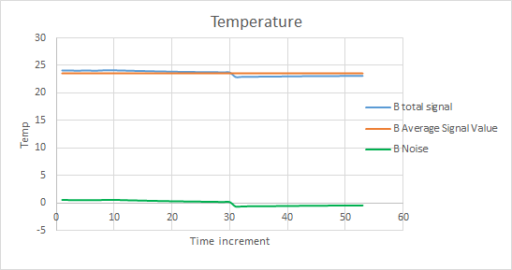

**Appendix E: Anemometer Calibration Data**

Information from compiled data graphs at wind tunnel frequencies ranging from 10 Hz to 22 Hz:

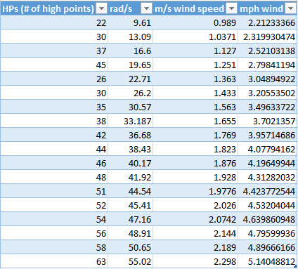

Analog output at minimum wind speed (1 m/s, 22 High Points)

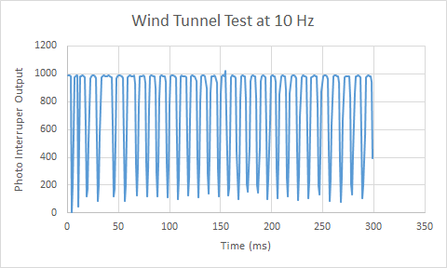

Analog output at 15 Hz:

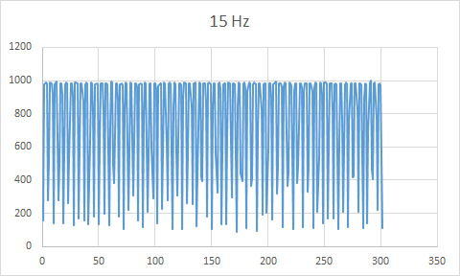

Analog output at 22 Hz:

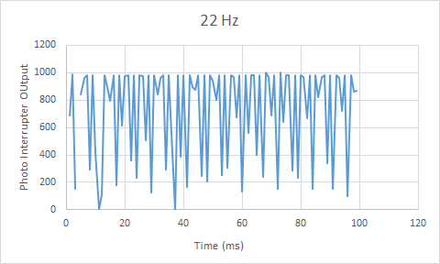

**Appendix F: Arduino IDE Code**[5].

/*

Thingspeak API Upload for BME 280 and Anemometer

*/

#include <Wire.h>

#include <SPI.h>

#include <Adafruit_Sensor.h>

#include <Adafruit_BME280.h>

#include <ESP8266WiFi.h>

#include <ThingSpeak.h>

#define BME_SCK 13

#define BME_MISO 12

#define BME_MOSI 11

#define BME_CS 10

#define SEALEVELPRESSURE_HPA (1013.25)

Adafruit_BME280 bme;

unsigned long delayTime;

#include <ESP8266WiFi.h>

const int analogInPin = A0;

int sensorValue = 0;

float sensorVoltage = 0.0;

float Windspeed = 0;

//Wifi Host

const char* ssid = "David's iPhone";

const char* password = "t72xk9toe178w";

WiFiClient client;

//Server Information

const char* host = "api.thingspeak.com";

const int postingInterval = 30 * 1000; // post data every 30 seconds to prevent missing points

// ThingSpeak Temperature Channel

const int TempchannelID = 252947;

String TempwriteAPIKey = "8MQNBPETGJFHQTET"; // write API key for your ThingSpeak Channel

// ThingSpeak Humidity Channel

const int HumchannelID = 252949;

String HumwriteAPIKey = "C7TM5S2GLDSG3YV6"; // write API key for your ThingSpeak Channel

// ThingSpeak Pressure Channel

const int PrechannelID = 255500;

String PrewriteAPIKey = "LIOXGIYPYUOR3VSU"; // write API key for your ThingSpeak Channel

// ThingSpeak Wind Channel

const int WindchannelID = 265952;

String WindwriteAPIKey = "PYE9PHFT8BYUQT0I"; // write API key for your ThingSpeak Channel

void setup() {

Serial.begin(115200);

delay(100);

Serial.println(F("BME280 test + Wifi + Thingspeak"));

bool status;

// default settings

status = bme.begin();

if (!status) {

Serial.println("Could not find a valid BME280 sensor, check wiring!");

while (1);

}

Serial.println("-- Default Test --");

delayTime = 5000;

Serial.println();

// Now we connect to a WiFi network

Serial.print("Connecting to ");

Serial.println(ssid);

WiFi.begin(ssid, password);

while (WiFi.status() != WL_CONNECTED) {

delay(500);

Serial.print(".");

}

Serial.print("");

Serial.print("WiFi connected");

Serial.println();

Serial.print("IP address: ");

Serial.println();

Serial.print(WiFi.localIP());

Serial.println();

int value = 0;

delay(5000);

++value;

Serial.print("connecting to ");

Serial.println(host);

Serial.println();

}

void loop() {

if (client.connect(host, 80)) {

// Measure Signal Strength (RSSI) of Wi-Fi connection- Collect values

float rssi = bme.readTemperature();

float rssi2 = bme.readHumidity();

float rssi3 = bme.readPressure() / 100;

// Show values that were measured

Serial.print('\n');

Serial.println("Weather Values");

printValues();

Wind();

float rssi4 = Windspeed;

//Create String using value

String body = "field1=";

body += String(rssi, 2);

//Create String using value

String body2 = "field1=";

body2 += String(rssi2, 2);

//Create String using value

String body3 = "field1=";

body3 += String(rssi3, 2);

String body4 = "field1=";

body4 += String(rssi4, 2);

Serial.print("Posting to Thingspeak");

Serial.println();

//Post on the Temperature channel

client.print("POST /update HTTP/1.1\n");

client.print("Host: api.thingspeak.com\n");

client.print("Connection: close\n");

client.print("X-THINGSPEAKAPIKEY: " + TempwriteAPIKey + "\n");

client.print("Content-Type: application/x-www-form-urlencoded\n");

client.print("Content-Length: ");

client.print(body.length());

client.print("\n\n");

client.print(body);

client.print("\n\n");

// Post on Humidity Channel

client.print("POST /update HTTP/1.1\n");

client.print("Host: api.thingspeak.com\n");

client.print("Connection: close\n");

client.print("X-THINGSPEAKAPIKEY: " + HumwriteAPIKey + "\n");

client.print("Content-Type: application/x-www-form-urlencoded\n");

client.print("Content-Length: ");

client.print(body2.length());

client.print("\n\n");

client.print(body2);

client.print("\n\n");

// Post on Pressure Channel

client.print("POST /update HTTP/1.1\n");

client.print("Host: api.thingspeak.com\n");

client.print("Connection: close\n");

client.print("X-THINGSPEAKAPIKEY: " + PrewriteAPIKey + "\n");

client.print("Content-Type: application/x-www-form-urlencoded\n");

client.print("Content-Length: ");

client.print(body3.length());

client.print("\n\n");

client.print(body3);

client.print("\n\n");

// Post on Windspeed Channel

client.print("POST /update HTTP/1.1\n");

client.print("Host: api.thingspeak.com\n");

client.print("Connection: close\n");

client.print("X-THINGSPEAKAPIKEY: " + WindwriteAPIKey + "\n");

client.print("Content-Type: application/x-www-form-urlencoded\n");

client.print("Content-Length: ");

client.print(body4.length());

client.print("\n\n");

client.print(body4);

client.print("\n\n");

delay(postingInterval);

Serial.println("Done Posting to Thingspeak");

// wait and then post again

}

client.stop();

}

//Windspeed function

void Wind() {

sensorValue = analogRead(analogInPin);

sensorVoltage = sensorValue * .00322266; // Convert from 0...1024 to 0...5v

//Serial.println("Sensor Value: ");

//Serial.print(sensorValue);

//Serial.println("Sensor Voltage: ");

//Serial.print(sensorVoltage);

Windspeed = ((sensorVoltage - .66) / (.04969136)) * 2.23694;

if (Windspeed >= 0) {

Serial.print("WindSpeed = ");

Serial.print(Windspeed);

Serial.print(" mph");

Serial.println();

}

if (Windspeed < 0) {

Serial.print("WindSpeed = ");

Serial.print(0);

Windspeed = 0;

Serial.print(" mph");

Serial.println();

}

}

//Sensor Function Outside loop

void printValues() {

Serial.print("Temperature = ");

Serial.print(bme.readTemperature());

Serial.println(" *C");

Serial.print("Pressure = ");

Serial.print(bme.readPressure() / 100);

Serial.println(" hPa");

Serial.print("Humidity = ");

Serial.print(bme.readHumidity());

Serial.println(" %");

}

**Appendix G: FS Anemometer Arduino IDE Codes**

This code output an analog value into the Serial Monitor from the photointerrupter input.

/* Analog Read Interrupter

* -----------------------

*/

int PhotoPin = A2; // select the input pin for the interrupter

int val = 0; // variable to store the value coming from the sensor

void setup()

{

Serial.begin(115200); // set up Serial library at 9600 bps

}

void loop()

{

val = analogRead(PhotoPin); // read the value from the sensor

//if (val < 300){

// Serial.println("BLOCKED");

// }

//else {

Serial.println(val); // print the sensor value to the serial monitor

delay(1);

// }

}

This code converted encoder HIGH output frequencies to a wind speed (buggy):

/* Analog Read Interrupter

* -----------------------

WITH CALIBRATION

*/

int PhotoPin = A2; // select the input pin for the interrupter

int HP = 0; //High Points in photo interrupt output

int outputs[500];

int val = 0;

void setup() {

Serial.begin(115200); // set up Serial library at 115200 bps

}

void loop() {

//GET DATA (0.5 sec)

//take a 0.5 second sample of data, load data into a vector to store

for (int i = 0; i < 500; i++){

int val = analogRead(PhotoPin); // read the value from the sensor

outputs[i] = val;

delay(1);

}

//FIND MAX VALUES IN DATA, GET HP VALUE

for (int j = 1; j < 500; j++) {

//find the high points; if a point is greater than the points

//around it and if its higher than 950, its a HP.

if (outputs[j] > 950 && outputs[j] > outputs[j-1] && outputs[j] > outputs[j+1]){

HP++;

}

}

//CALCULATE AND PRINT VELOCITY

int x = HP*0.131;

int rads = x/0.5; //[rad/s]

// v = sqrt(2gh), but use the calibration v = 0.03(rads) + 0.6622

int velocity = 0.03*rads + 0.6622;

Serial.println(val); // print the sensor value to the serial monitor

Serial.println(velocity);

delay(6000); //delay 1 min before taking another 10 s sample

}

**Appendix H: CAD Drawings**

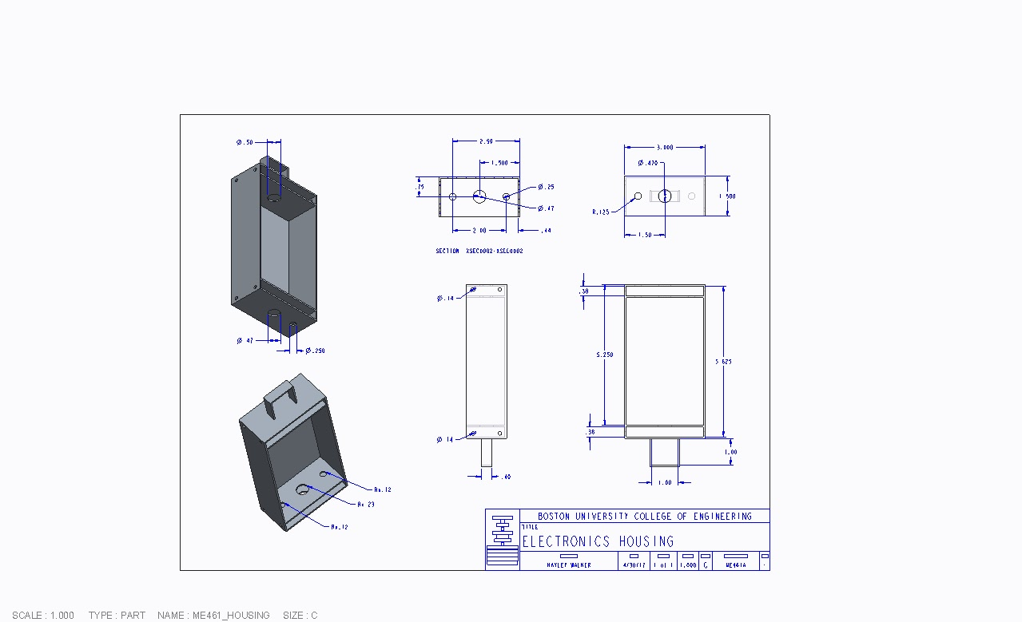

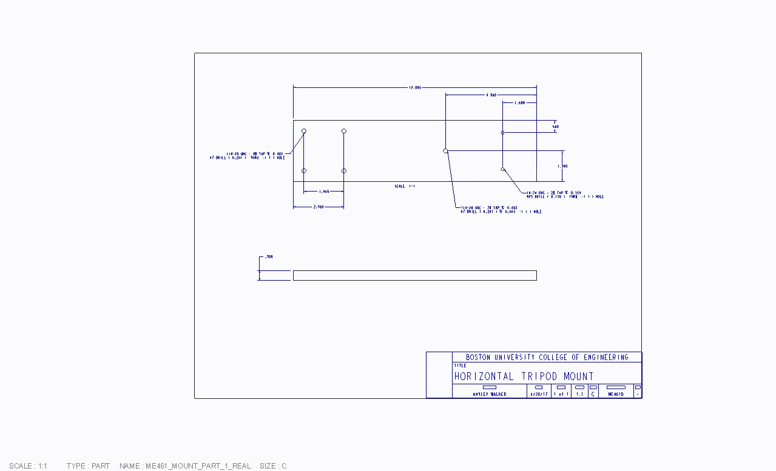

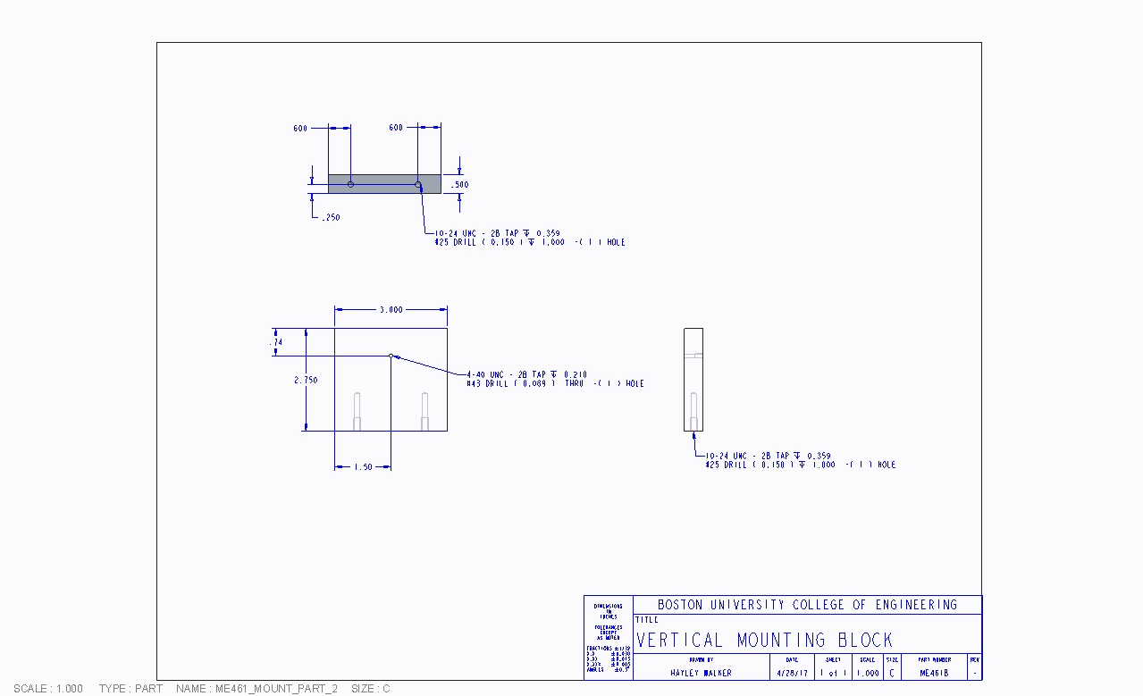

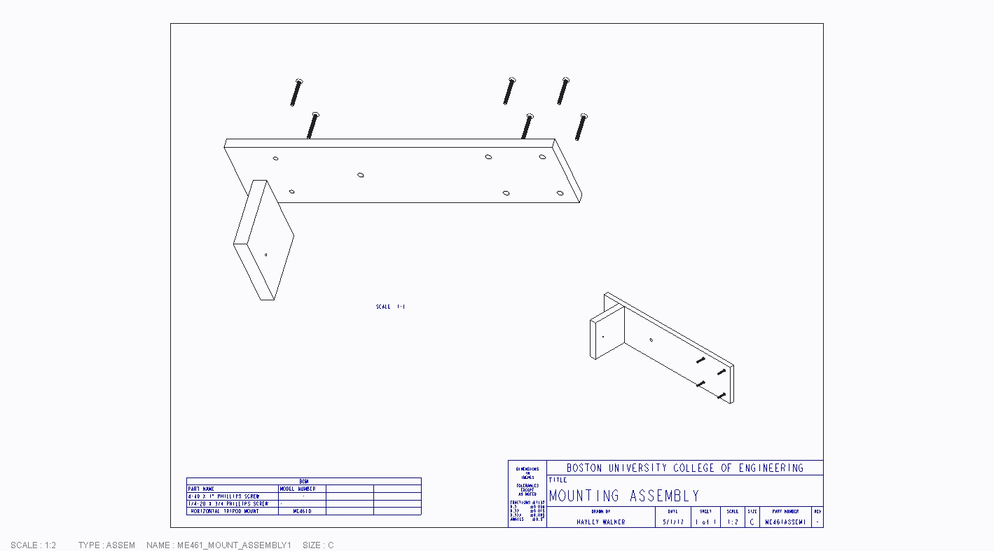

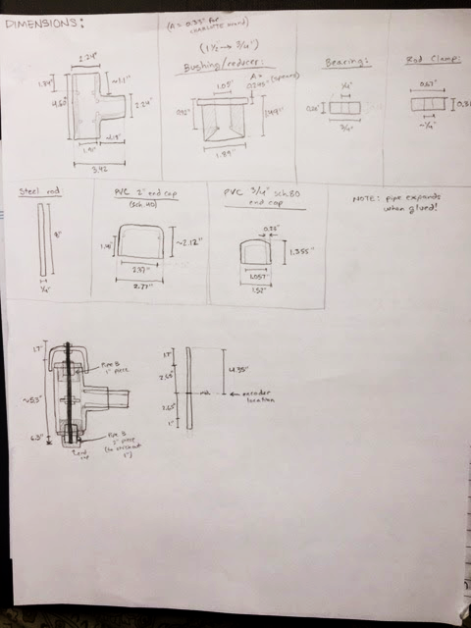

**Appendix I: GLOBE Specifications**

|  |  |  |
| --- | --- | --- |
| **Measureable:** | **Accuracy (+/-)** | **Measurement Frequency** |
| Temperature | 0.5˚ C | Daily |
| Pressure | 0.1 mbar | Daily |
| Humidity | 5% | Daily |
| Wind Speed | N/A | Daily |

**Appendix J: Gantt Chart**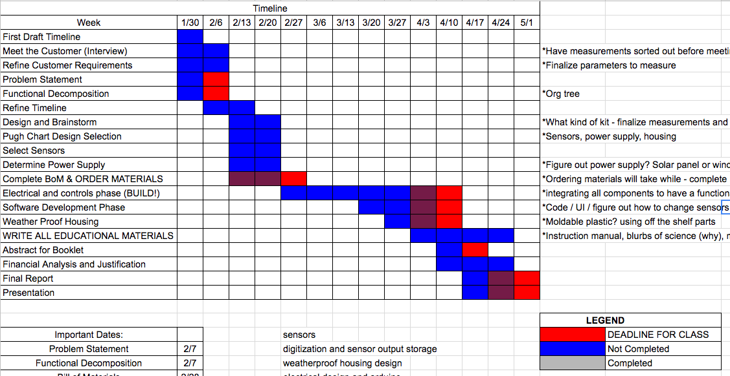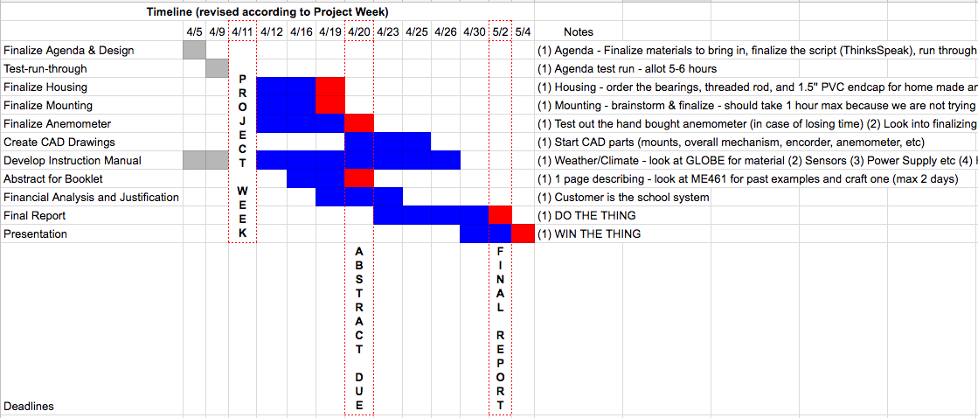

**Appendix K: Project Week Agenda**

**Timeline:**

* + Tuesday April 11 from 9 am - 3 pm
    - Arrive at BU [Marsh Plaza] around 9 - 9:30 am
    - Tour of [EPIC] from 9:30 - 9:50 am
    - Introduce workspace & project from 10:00 - 11:45 am (Part 1 and Part 2)
      * Prof. Farny
    - Lunch from 12 - 12:30 pm
    - Work on sensors & implementing the device from 12:40 - 2:30 pm (Part 3)
      * Prof. Gutierrez
    - Student Panel from 2:30 - 3 pm

**Agenda:**

**This is our intro into our project:**

Part 1: Introduction to GLOBE and citizen science (15-20 minutes → 10:00-10:20am)

**Big Question: why would you want to build your own weather station?**

**A.) #Engineering and we how we CAN do it ourselves** (10:00 - 10:06 pm)

* Society has advanced to the point where we now have inexpensive instrumentation (sensors and inexpensive, accessible, and flexible computing power), a large online support community (free expertise), and readily-accessible database tools to log and share the data.

**B.) Knowledge is power** (10:06 - 10:12 pm)

* There’s a growing sense that it’s important to know more about our planet’s environmental picture: The average temperature is increasing but planetary thermodynamics is incredibly complex and we can’t fully understand it without more data. This is why GLOBE exists.

**C.) Big picture vs local picture** (10:12 - 10:18 pm)

* Government policy is driven by societal need. We have federal agencies that act on nation-wide data but local state & city agencies also need this information. The city of Boston has its own health to monitor, and local environmental data is important as well.

**We can introduce a little bit of product design and Arduino use in this portion of the day as well:**

Part 2: The engineering behind the weather stations (10:20 - 11:45)

**A.) Fenway teacher present about the weather (20 minutes)** (10:20 - 10:40)

Before we go into the sensors that measure our weather, we need to talk about what we are measuring today.

*Temperature, Humidity, Pressure → Fenway High School teachers?*

**B.) The sensors (15 minutes)** (10:40 - 10:55)

Talk about why we chose the sensors that you did, what they measure, and how they measure. Don’t overestimate their understanding of the electrical aspects of this topic: output voltage, power requirements, etc. Most of these students may not have a good feel for what voltage and current are! Don’t get technical — just stay close enough to the big picture description and why it’s important to appreciate for this project.

**C.) The Arduino (50 Minutes)** (10:55 - 11:45)

We can introduce an arduino to the students and do some basic activities with them. The are example codes on Arduino IDE, some good examples can involve LEDs and then a dc motor. Professor Gutierrez has kits of his own and has held Arduino activities

~ **BREAK FOR LUNCH** ~

**This would be the last part of our day:**

Part 3: The build (12:30 - 2:30)

**A.) Divide and Conquer** (15 minutes → 12:30 - 12:45)

* To help in coordinating all of the students we can designate smaller subgroups for each of the following
* The wireless module & programming, testing and hooking up
* The housing, this can be rudimentary as the group could just play with cardboard (15 min)
  + OR USE TUPPERWARE
* The sensors, testing and hooking up (15 min)

**B.) Test!** (60 minutes → 12:45 - 2:00)

* Check to see if all of the components are working, and then as a team put it together and test it! (15 min → 12:45 - 1:00)
* We can have the students bring their stations outside and collect data (30 minutes → 1:00 - 1:30)
* Each group would need a teacher/Student who could create a hot spot
* To conclude this we can bring the students back and show the emails/**Thingspeak** (10 minutes → 1:30-1:40)
* Wrap up presentation (10 minutes → 1:40-1:50)

**C.) Surveys** (10 min → 1:50 - 2:00 pm)

* Get video clips throughout the day of the students interacting with our weather station

**D.) Student Panel** (30 min → 2:00 - 2:30)

* We answer any questions that students may have

NOTES: WE HAVE AN EXTRA **30 MINUTES** TO USE ANYWHERE - WE NEED TO TEST RUN THIS

**Appendix L: Data Graphs from Gutierrez Weather Station**

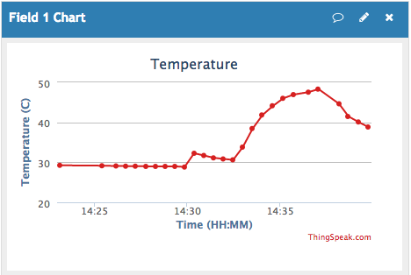

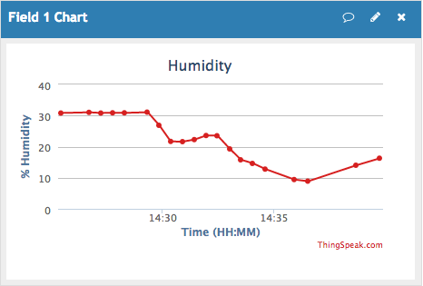

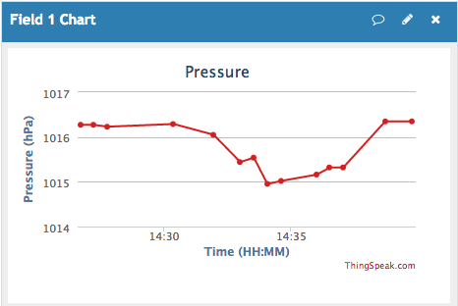

This data was collected during the Fenway High School Project Week from the weather station built by the students. Wind speed was not taken that day. The students started data collection inside for roughly 10 minutes, then went outside.

**Extended Period Testing**

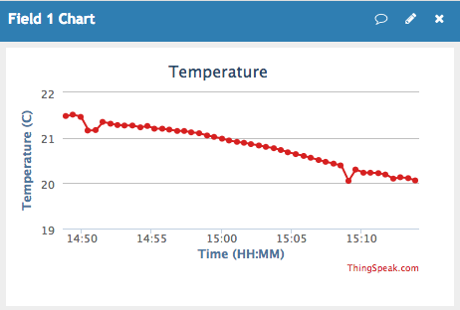

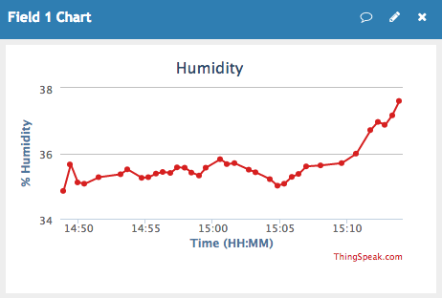

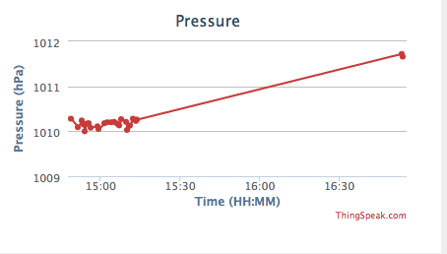

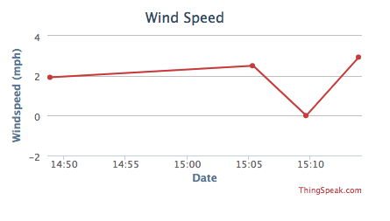

**Time (HH:MM)**

These graphs represent data taken outside for 30 minutes. The pressure screenshot was taken after the station was brought back inside, whereas the other graphs were taken before.

1. <https://www.globe.gov/about/overview>
2. <https://www.bu.edu/stem/2015/04/20/weather-station-provides-hands-on-instruction-at-webster-avenue-elementary/>
3. https://www.globe.gov/about/overview
4. http://www.davisnet.com/solution/vantage-vue/
5. <https://www.bu.edu/stem/2015/04/20/weather-station-provides-hands-on-instruction-at-webster-avenue-elementary/>

   6 Parts of code written by Limor Fried & Kevin Townsend for Adafruit Industries.